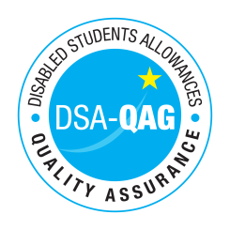
The Northern School of Art - NMH Rates

The table below shows NMH rates. The greyed out cells indicate that the NMH provider does not offer these services.

Note: NMH Support Rates shown per hour in the table below.
 | Standard Rate (in-person) |  |  | Distance Learning only (in-person, in-home |  |  | Remote Delivery (e.g. Facetime/Skype or similar) Only
Band 1 Support Assistants | Net | VAT | Total | Net | VAT | Total | Net | VAT | Total
Practical Support Assistant
Library Support Assistant
Reader
Scribe
Workshop / Laboratory Assistant
Sighted Guide
Proof Reader / text checker
Band 2 Enhanced Support Assistants
Study Assistant
Examination Support Worker
Note Taker
Band 3 Specialist Enabling Support
Communication Support Worker
Lip Speaker
Specialist Note taker (Deaf/Hard of Hearing students) including Electronic Note Taker and Speech to Text Reporter
Specialist Note taker (VI students) including Braille
Specialist Transcription Service
Mobility Trainer
Band 4 Specialist Access and Learning Facilitators
Specialist Mentor – Mental Health
Specialist Mentor – AS
Specialist 1:1 Study Skills Support - SpLD | 58.50 | 0 | 58.50
Specialist 1:1 Study Skills Support - AS
BSL Interpreter - includes Interpreter for the deaf or Deafblind People
Assistive Technology Trainer
Specialist Support Professional for Deaf students
Specialist Support Professional for students with Vision Impairment
Specialist Support Professional for students with Multi-sensory impairment (MSI)
*Please delete any rows where you do not provide this support role

