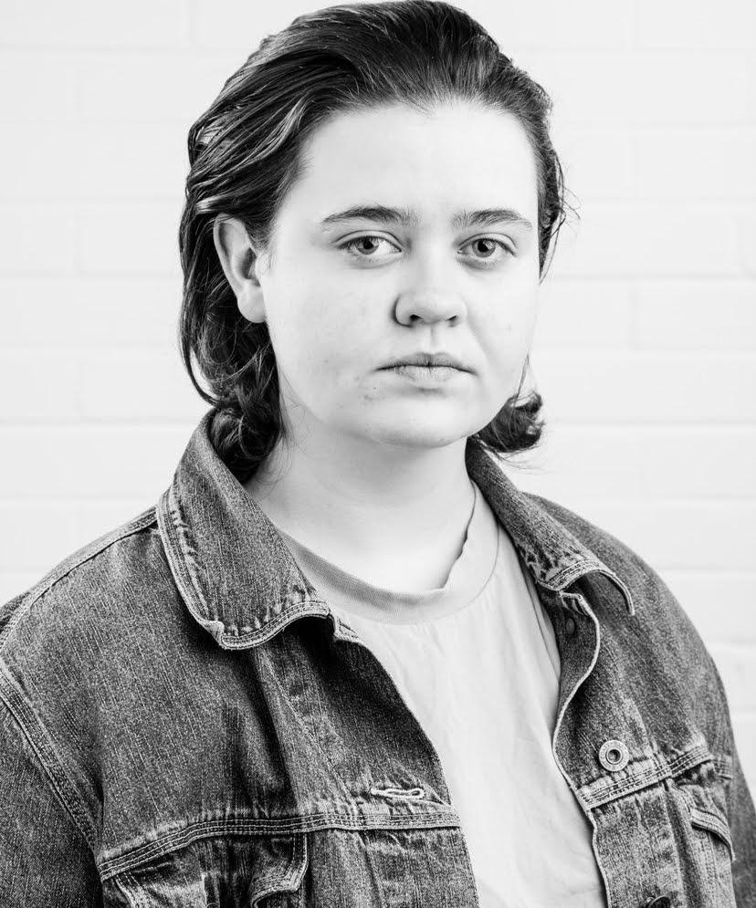
Gemma Blake
Email: gemma.010.acting@gmail.com Tel: 07533227226
Web: TBC
D.O.B: 05/12/2000
HEIGHT: 5ft 5inches
EYES: Green
HAIR: Dark Brown
EDUCATION:
BA (Hons) Acting for Stage and Screen at The Northern School of Art. (Grad. 2022)
Level 3 Advanced Diploma in Performing Arts at Burnley College and Sixth Form Centre. (Grad. 2019)
SKILLS:
Puppetry, Devising, Ukulele (amateur), Musical Theatre, Directing, Puppet Making, Physical Theatre, Drumming.
Accents & Dialects:
Lancashire (Native), General American, Broad Northern & General Scottish (Amateur)
Workshops with:
Maria Crocker, Frantic Assembly, Tony Jayawardena, Gyre and Gymble, Pineapple Studios, Racheal Teate, Ishy Din, Ruth Mary Johnson, Fuel Theatre.
Other Experiences:
Stage Combat (amateur), Puppetry (intermediate)
CREDITS:
Role | Title of the piece | Director | Company | Type | Year
Billie | Get Loud | Danni Clarke | Menstrual Rage Ltd | Stage | 2022
Norah | Incense and Bleach | Jonathan Bussell | The Northern School of Art | Stage | 2022
Defence, Victim, Detective & Colleague | Hands Up | Thalia Martin | Moonchild Productions | Stage | 2022
Molly | Super Happy Amazing Burger Time | Joseph Casling | Trip Up North | Radio | 2022
Mother | A Story of Love and Interplanetary Warfare | Robbie Tweedale | The Northern School of Art | Screen | 2022
Envy | Rainy Days | Thalia Martin | Moonchild Productions | Radio | 2022
Ellie | Ghosted | Anna Bant | The Northern School of Art | Screen | 2021
Puppeteer | Newcastle Puppetry Festival | Devised ft. William Steele | Newcastle Puppetry Festival | Screen | 2021
Miller | The Four Horsemen | Robbie Tweedale, Jack Colley, Anna Bant and Oscar W. Fitchett | The Northern School of Art | Screen | 2021
Chorus | Antigone | Jonathan Bussell | The Northern School of Art | Recorded Theatre | 2021
Ann | This is a Chair | Thalia Martin, Samuel Burt & David Edwards | The Northern School of Art | Recorded Theatre | 2021
Ms Morgan Thornton | Educating Sunny Hill | David Edwards & Andy Berriman | The Northern School of Art | Screen | 2020
Zeus & others | Blast from the Past | Devised | The Northern School of Art | Radio | 2020
Puppeteer | Hartlepool Monkey Project | Devised ft. Ruth Mary Johnson | Gyre and Gimble & Fuel Theatre | Screen | 2020
Police 4 | Rage | Jonathan Bussell | The Northern School of Art | Stage | 2020
Party Goer | The Home:  Durational Stay | Christopher Green | ARC Stockton | Immersive | 2019
Clown | Clowning Around | Mel Robbins | Burnley College | Stage | 2019
Bert | Mary Poppins Jr | Katie Lake | Burnley College | Stage | 2019
Scare Actor | Grave Diggers | Scare Kingdom | Scare Kingdom Scream Park Ltd | Stage/ Immersive Theatre | 2019
Ensemble | Elf Jr | Katie Lake | Burnley College | Stage | 2018
Reecey | Our House Jr | Matthew Olyott | Shuttleworth College | Stage | 2018
Ms Hannigan | Annie Jr | Lorna Pennington | Shuttleworth College | Stage | 2017

