Tom Maddocks 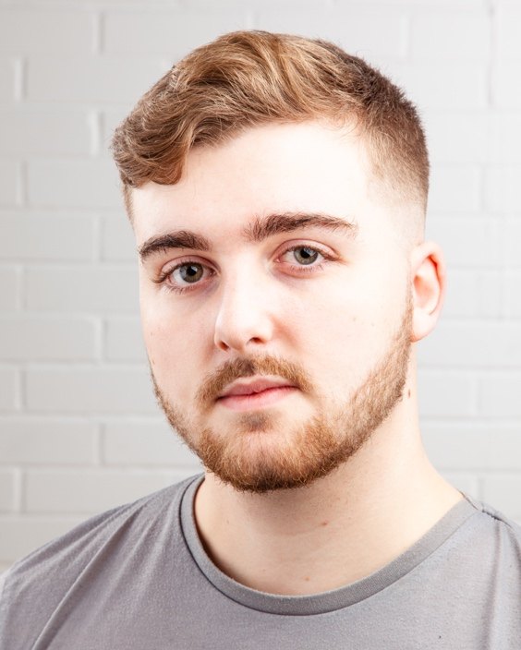
Email: tom.o.maddocks@gmail.com
Tel: 07527278709
D.O.B: 19/12/2001 HEIGHT: 6”0
EYES: Green HAIR: Brown, Short
EDUCATION: BA (Hons) Acting for Stage and Screen

SKILLS: UK Driving Licence, Script Writing, Improvisation, Devising, Voice Acting, Song Writing
Accents & Dialects: Manchester (Native), Scottish, RP, Cockney, New Zealand, American (General)
Music: Singing, Rapping, Producing. Instrument: Piano.
Sports: Football, Trained Football Referee
Other Skills/Experience:
Stage Combat Workshop, Script Writing, Puppetry Workshop
CREDITS:
Role | Title of Piece | Director | Company | Type | Year
Jackson | When All That’s Left | Katy Weir | Northern School of Art | Theatre | 2023
Kolone / Frederick | Nighthood | Stephen Lister | Northern School of Art | Radio | 2023
Mr. Watson | Welcome to the Village | Kaitlyn Maxfield | Northern School of Art | Theatre | 2023
Finley | Making Your Acquaintance | Ella Patience | Northern School of Art | Film | 2023
Myself | Hung, Drawn, and Quoted | Kyle Flynn | Northern School of Art | Live Television | 2022
Danny | Bridge Town | Erin Thomson and Rin Stannard | Northern School of Art | Television | 2022
Antonio / Carl | The Duchess of Malfi | David Edwards | Northern School of Art | Theatre | 2022
Charlie | Midnight | Anna Bant | Northern School of Art | Film | 2022
Dylan Short | The Disappearance of Lara Moore | George Dickson | Northern School of Art | Documentary | 2022
Nick/ Multiple Roles | Hump Day Radio | Group Devised | Hump Day Radio | Radio | 2021
David | I Had Such a Good Weekend | Eve Colpitts | Northern School of Art | Film | 2021
Mark | Woyzeck | David Edwards | Northern School of Art | Film | 2021
Charlie Moxon | Reasons to be Cheerful (Part 4) | Group Devised | Northern School of Art | Documentary | 2021
Matt | Him & Her | Arianne Frampton | Northern School of Art | Theatre | 2020
Mark | Want | Leigh Hayes | The Manchester College | Theatre | 2019
Richard | DNA | Tom Maddocks | Partington Theatre | Theatre | 2019

