LJ Watt 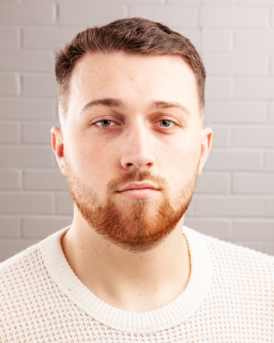
Email: Lathanieljwatt@yahoo.com
Tel: 07810 377749
D.O.B: 2/9/01 HEIGHT: 6 “2
EYES: Blue HAIR: Brown
EDUCATION: Currently studying BA (Hons) Acting for Stage and Screen at The Northern School of Art. SKILLS: Driving license, Comedy Improv
Accents & Dialects: Hampshire accent (Native)- originally from Suffolk- General American
Sports: Running, cycling
Other Skills/Experience:
Puppetry
CREDITS:
Role | Title of Piece | Director | Company | Type | Year
Jack Woodhouse | The Last to Leave the Party | Rachel Thomas | The Northern School of Art | Film | 2022
Manager | Cocktails | Elizabeth Porter | The Northern School of Art | Film | 2022
Arturo | Off the Wall | Jake Smith | The Customs House | Play | 2022
Magic Mcjagger the Magician | What a Day | Sherkeighra Garnham | The Northern School of Art | Variety Show | 2022
Narrator | Manhole 1999 | Rachel Teate | BBC | Radio play | 2022
Sergeant Chambers | Life Changing | Rachel Thomas | The Northern School of Art | Film | 2022
Alan/ Roderigo | The Duchess of Malfi | David Edwards | The Northern School of Art | Play | 2022
Sam McAlister | The Disappearance of Lara Moore | George Dickson | The Northern School of Art | Film | 2021
Gabriel | Reasons to be Cheerful Part.4 | David Edwards | The Northern School of Art | Film | 2021
Boy | Grief | Kieran Graham | The Northern School of Art | Film | 2021
Spencer | Woyzeck | David Edwards | The Northern School of Art | Film | 2021
Jeremy | The Hostage | Abbigail Bustin Mulkern | The Northern School of Art | Stage | 2021

