Kaitlyn Maxfield
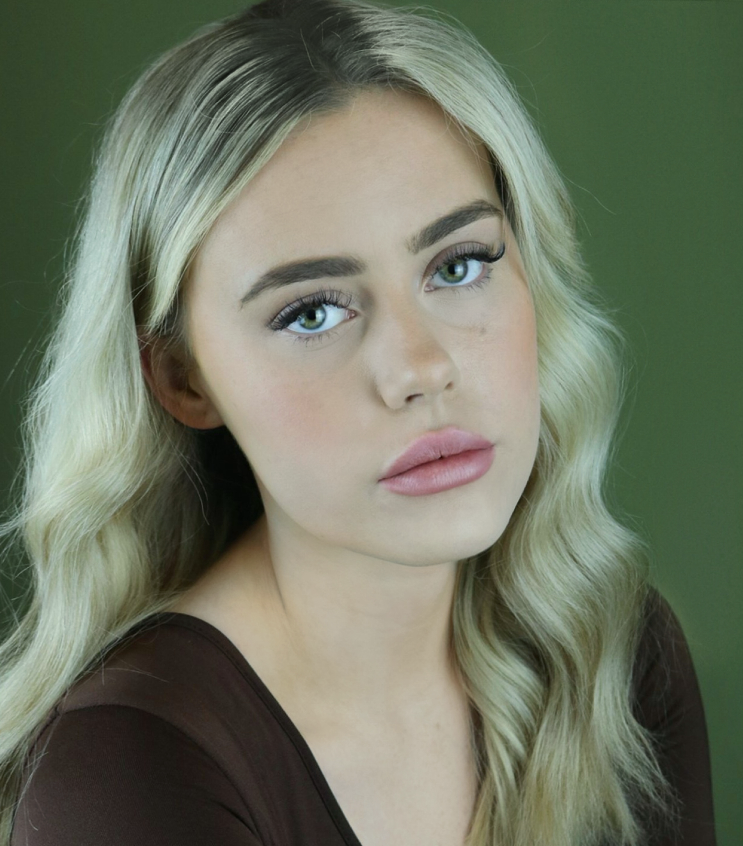
D.O.B: 03/06/2000 HEIGHT: 5’7
EYES: Hazel HAIR: Blonde Highlighted Mid Length
Email: kaitmaxfield@icloud.com
Tel: 07544772178
EDUCATION: BA Hons Acting for Stage and Screen
National Youth Theatre Member
LAMDA Grade 6 Reading for Performance
SKILLS: Script writing, DBS checked, Improvisation, Devising, Musical Theatre, Puppetry, Directing, Physical Theatre, Comedy
Accents & Dialects: Lancashire (Native), Welsh, RP, Standard American, Essex, Southern American, Yorkshire
Music & Dance: Singing; Top D Belt, Mezzo, Trained Legit singing, Trained Musical Theatre singing. Dance; Trained minimal contemporary dance, Trained minimal musical theatre dance.
Sports: Football, Hockey
Other Skills/Experience:
National Youth Theatre Intake Course (2020), Children’s Entertainer
CREDITS:
Role | Title of Piece | Director | Company | Type | Year
Mary Martin Of Tours | Sister Act | Michael Cosgrove | Musical Theatre Training Academy | Stage | 2019
Sarah Caroll | Woyzeck | David Edwards | Northern School Of Art | Film | 2021
Amy | Him and Her | Arianne Frampton | Northern School Of Art | Stage | 2021
Bianca | Therefore, I Am | Ella Patience | Northern School Of Art | Film | 2021
Katrina | Reasons To Be Cheerful Part.4 | David Edwards | Northern School Of Art | Film | 2021
Amanda | The Disappearance of Lara Moore | George Dickson  Connor Lovett | Northern School Of Art | Film | 2021
Daniel de Bosola | The Duchess Of Malfi | David Edwards | The Northern School Of Art | Stage | 2022
Miss Jackson | Bridgetown | Erin Thompson | The Northern School Of Art | Film | 2022
Jessie | Mondegreen | Tom Maddocks | The Northern School Of Art | Stage | 2023
Lucentia | (The Taming of) The Shrew | Hannah Ould | Menstrual Rage | Stage | 2023

