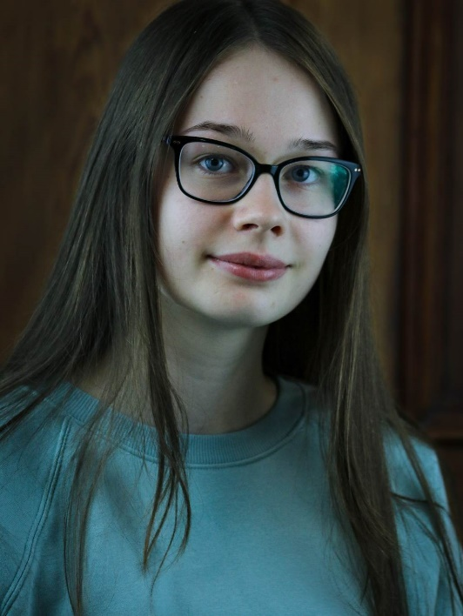
Lucy Olivia
Email: lucyoliviaacting@gmail.com
Tel: +44 7463969693
D.O.B: 08/04/2002 HEIGHT: 5’7”
EYES: Blue HAIR: Brown, Long
EDUCATION: BA (Hons) Acting for Stage and Screen at The Northern School of Art (Graduating year: 2023)

SKILLS:
Accents & Dialects: North East (Native), American (Standard), General Australian English, East End (Cockney)
Other Skills/Experience: Full UK Drivers Licence, Singing (Mezzo Soprano), Proficient Swimmer
CREDITS:
Roles | Title of Piece | Director | Company | Type | Year
Chloe | When All That’s Left | Katy Weir | Northern School of Art | Stage | 2023
Alyson | Indication | Alys Lawrence | Northern School of Art | Screen | 2023
The Curious Cat | The Grumpy Owl, The Curious Cat and The Lonely Witch | Lucy Olivia | Northern School of Art | Radio | 2023
Alex | Mondegreen | Tom Maddocks | Northern School of Art | Stage | 2023
Fanny Gabor | Spring Awakening | Maria Crocker | Less is More Productions | Stage | 2022
N/A | Manhole 1995 | Rachel Teate | BBC | Radio | 2022
Silvia | The Duchess of Malfi | David Edwards | Northern School of Art | Stage | 2022
Doris/ Dr. Heather Higgins | Abandoned Truths | Group Directed | Northern School of Art | Podcast | 2021

