Teddy Alexandra
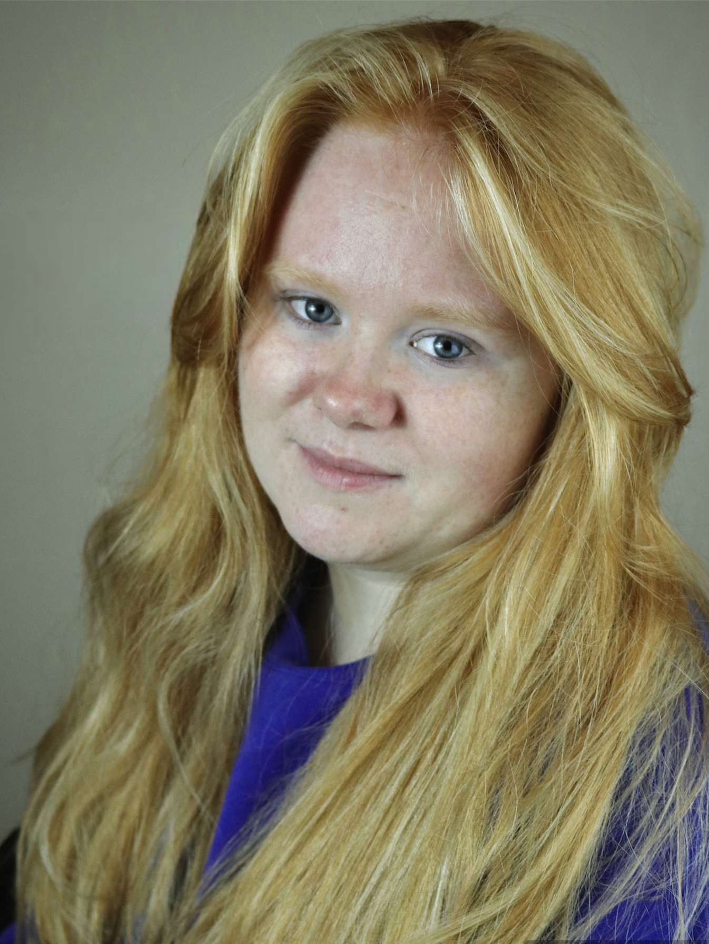
Email: creative@teddyalexandra.co.uk
Tel: 07871798446
D.O.B: 01/09/2001 Playing Age: 14-22 years
HEIGHT: 5’0 EYES: Blue/Grey HAIR: Ginger, Medium
EDUCATION: Northern School of Art BA Hons Acting for Stage and Screen
SKILLS: Full UK Drivers Licence, Devising, Improvisation
Accents & Dialects: West Midlands (Native), Birmingham, General American
Music & Dance: Grade 8 Singing, Mezzo Soprano/Alto, Acapella, Piano (adequate)
Sports: Hockey (highly skilled), Horse Riding (skilled), Netball (skilled), Ice-skating (adequate)
Other Skills/Experience: Puppetry, Physical theatre
CREDITS:
Role | Title of Piece | Director | Company | Type | Year
Kelsie | Echo | Devised by Teddy Alexandra, Jess Jervis-May, Anna-Rose Kaye, Phoebe Hunter, Sarah Webber | Northern School of Art | Movement | 2023
519/Amanda Grey | 519 | Kieran Erdis | Northern School of Art | Short Horror Film | 2023
Peter | Welcome to the Village | Kaitlyn Maxfield | Northern School of Art | Farce comedy | 2023
Coworker 1 | Intricate Innards of Human Beings | Kyle Flynn | Northern School of Art | Short Coming-of-age Film | 2023
Jamie | Mondegreen | Tom Maddocks | Northern School of Art | Stage | 2023
Gordon Shakespeare | Nativity! The Musical | Fiona Walker | Casting Call | Musical | 2022
Martha | Spring Awakening | Maria Crocker | Less is MORE | Musical | 2022
Molly | Freed | Jess Harvey | Woven Ink | Animation (unreleased) | 2022

