Phoebe Hunter
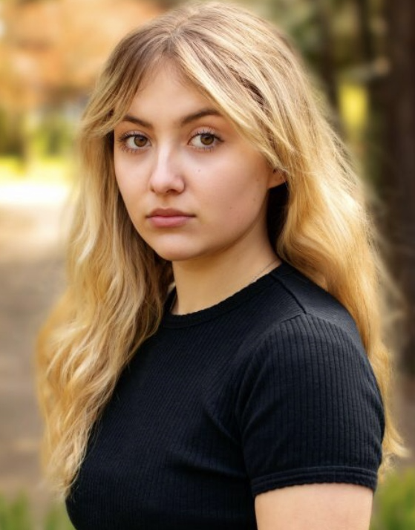
Email: phoebe.hunter02@gmail.com
Tel: 07964387496

D.O.B: 23/08/2002 HEIGHT: 5’3
EYES: Brown HAIR: Blonde, Curly, Long
EDUCATION: BA (Hons) Acting for Stage and Screen at The Northern School of Art.
SKILLS: Directing, Devising, Improvising, Script Writing, Frantic Assembly, UK Driving Licence, Ukulele.
Accents & Dialects: General Northern, RP (Native), Irish, Welsh, General American.
Music & Dance: Soprano, Basic Musical Theatre.
Sports: Swimming (highly proficient), Hockey, Roller-Skating.
Other Sills/Experience: Exploring Shakespeare Course at RADA, Children’s entertainer, 4 years at Pauline Quirk Academy.
CREDITS:

Role: | Title of Piece: | Director: | Company: | Type: | Year:
Abigail | ‘When all that’s Left’ | Katy Weir | The Northern School of Art | Stage | 2023
Jen | ‘The Intricate Innards of Human Beings’ | Kyle Flynn | The Northern School of Art | Film | 2023
Beans/Peas | ‘Fireside Stories with Father Christmas’ | Sophie Brown | Raby Castle Estates | Stage | 2022
Duchess of Malfi | ‘The Duchess of Malfi’ | David Edwards | The Northern School of Art | Stage | 2022
Harriet/Mrs Elton | ‘Emma’ | Hannah Ould | Menstrual Rage | Stage | 2021

