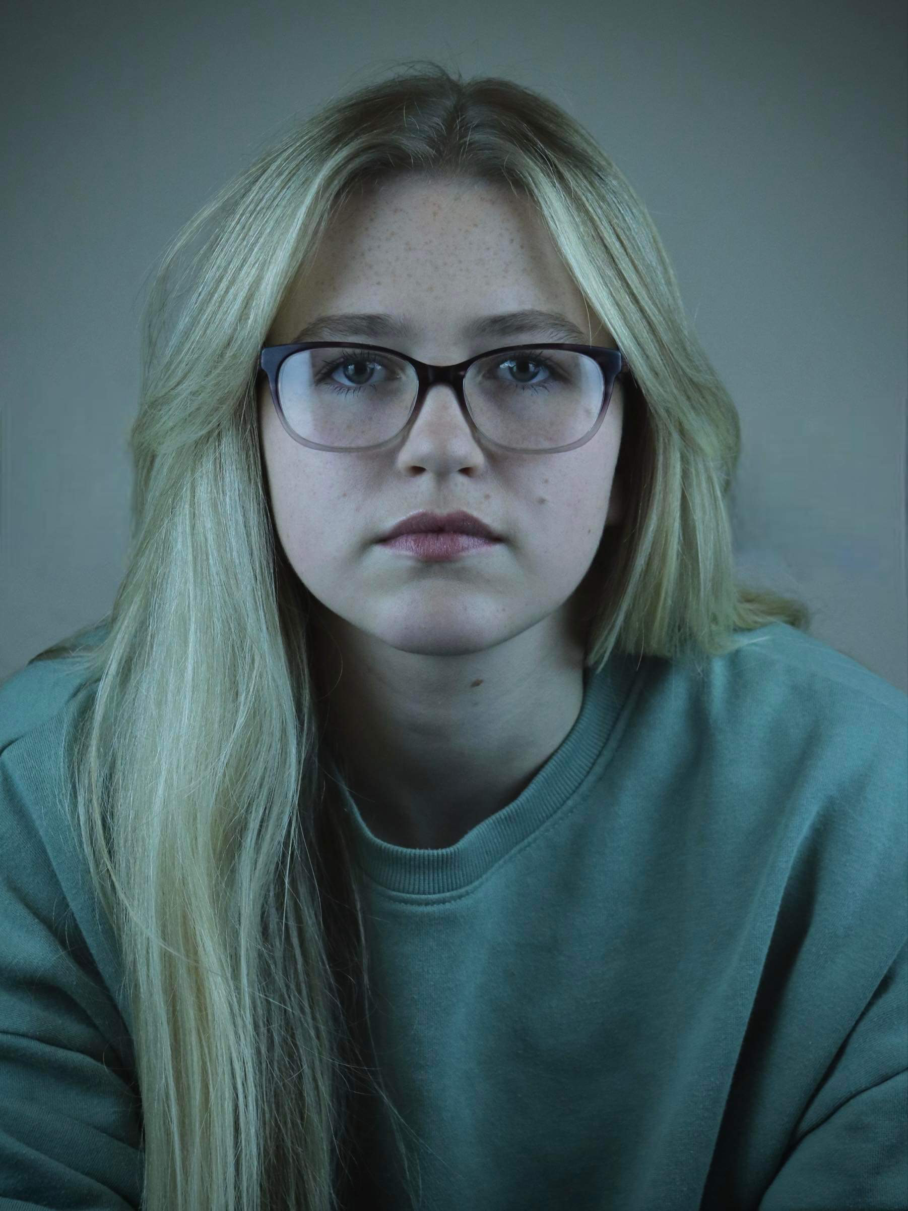
Anna-Rose Kaye
Email: annarosekaye.acting@gmail.com
Tel: 07794548302

D.O.B: 23/10/1999 HEIGHT: 5’4
EYES: Green HAIR: Blonde
EDUCATION: BA Hons Acting for Stage and Screen

SKILLS:
Accents & Dialects: Cumbrian (RP)(Native), American (Standard)
Music & Dance: Soprano/Mezzo Soprano, Basic dance skills.
Sports: Proficient Swimmer
Other Skills/Experience:
Experience in teaching Dance, Drama and Singing to kids aged between 5-16.

CREDITS:
Role | Title of Piece | Director | Company | Type | Year
Abby/Tabitha Abbott | Switched | Phoebe Hunter | The Northern School of Art | Stage | 2023
Annie | Echo | Devised by: Anna-Rose Kaye, Jess Jervis-May, Phoebe Hunter, Sarah Webber, Teddy Alexandra | The Northern School of Art | Devised movement | 2023
Dr. Marshall | Welcome to the Village | Kaitlyn Maxfield | The Northern School of Art | Stage | 2023
Wendla Bergman | Spring Awakening | Maria Crocker | Less is MORE | Musical | 2022
Multi-role Throughout | And Me | Hannah Burnside | Menstrual Rage Theatre | Stage | 2022
Anna | Attract the Dogs | Tom Maddocks | The Northern School of Art | Screen | 2022
Ruby & Lara Moore | The Disappearance of Lara Moore | David Edwards & George Dickson | The Northern School of Art | Screen | 2022
Ashley | Cafe D’amour | Leo Bradley | The Northern School of Art | Screen | 2021

