Abbi Mercer
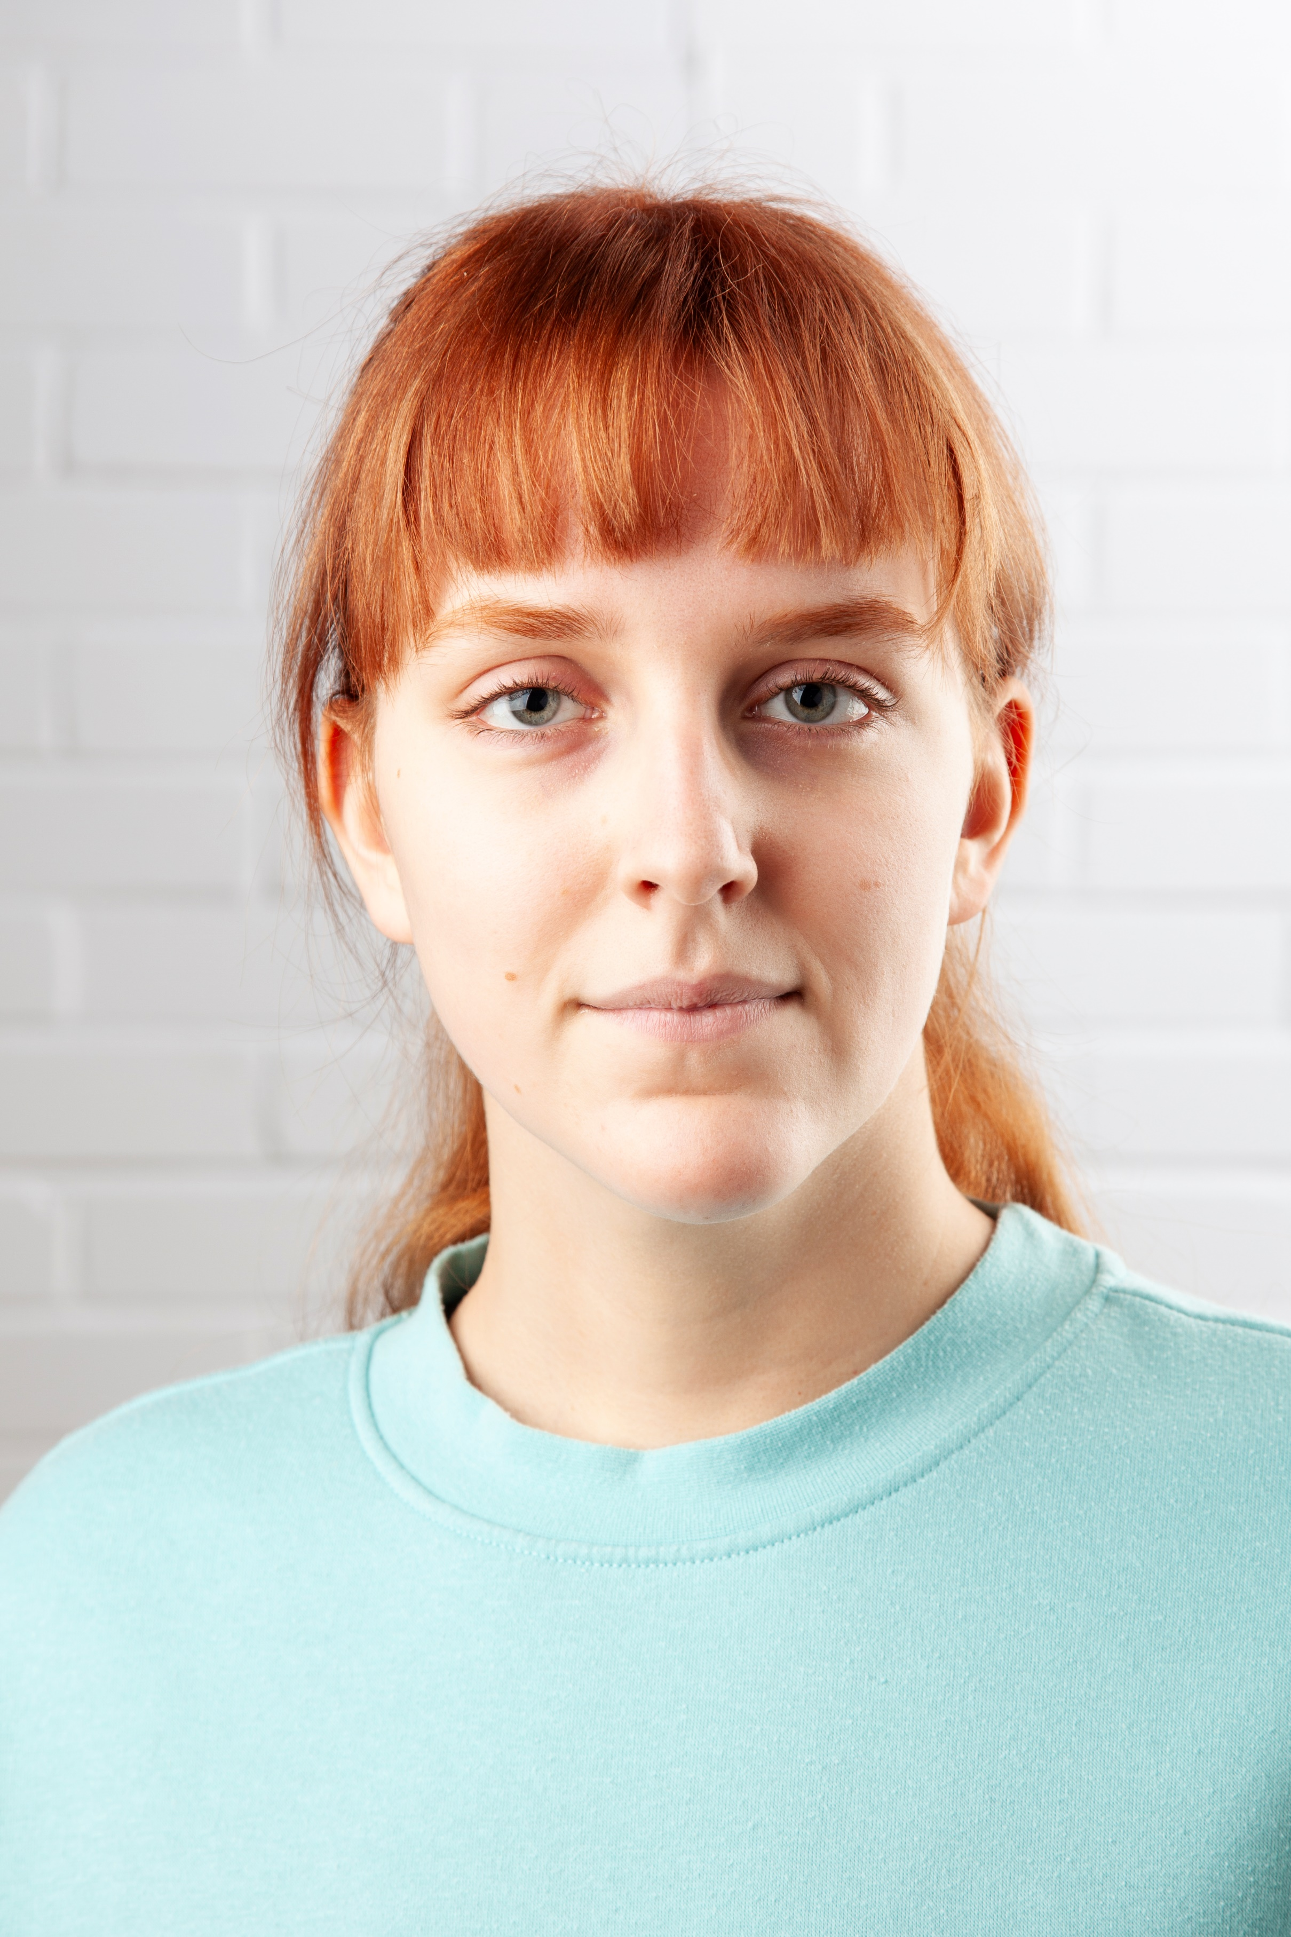
Email: merceraj35@gmail.com
Tel: 07523692751

D.O.B: 08/10/2002 HEIGHT: 6ft
EYES: Blue HAIR: Auburn/Red – dark blonde natural
EDUCATION: BA (Hons) Acting for Stage and Screen – The Northern School of Art, Graduating 2024
SKILLS: Speak moderate Swedish, moderate French
Accents & Dialects: (Native) Yorkshire, French, RP, General American, Southern American
Music & Dance: violin
Sports: Running, Yoga, Pilates, Swimming, Cross trainer

CREDITS:
Stage
Role | Title of Piece | Director | Company | Type | Year
Ella Jones | Fake News | Abbi Mercer | The Northern School of Art | Stage | 2023
Third Witch/ Caithness | Macbeth | Jonathan Bussell | The Northern School of Art | Stage | 2023
Susan Ridge-pipe | Murder Mystery | Maggie Marsden | Laycock Players | Stage | 2023
Jo/  Josie | Conspiracy Crew | David Edwards | The Northern School of Art | Radio | 2022
Shannon Woodlock | ANT-TV | David Edwards | The Northern School of Art | Screen | 2022
P.C. | Life Changing | Hannah Trafford | The Northern School of Art | Screen | 2022
Ensemble | Love and Information | Katy Wier | The Northern School of Art | Stage | 2022
Mrs. Smythe Welling | The Lady from Maxim’s | David Edwards | The Northern School of Art | Stage | 2022
The Mad Hatter | Alice | Susan Hargreaves | Craven College | Stage | 2021
Ensemble/ Customer | Little Shop of Horrors | Giles Atkinson | Craven College | Stage | 2020

Screen
Role | Title of Piece | Director | Company | Type | Year
Higher One 1 | Feel | Natasha Drymon | The Northern School of Art | Screen | 2024
Shannon Woodlock | ANT-TV | David Edwards | The Northern School of Art | Screen | 2022
P.C. | Life Changing | Hannah Trafford | The Northern School of Art | Screen | 2022
Nurse | Losing Sarah | Curtis Burnett | The Northern School of Art | Screen | 2022
Radio
Role | Title of Piece | Director | Company | Type | Year
Jo/Josie | Conspiracy Crew | David Edwards | The Northern School of Art | Radio | 2022

