Luke Swainson
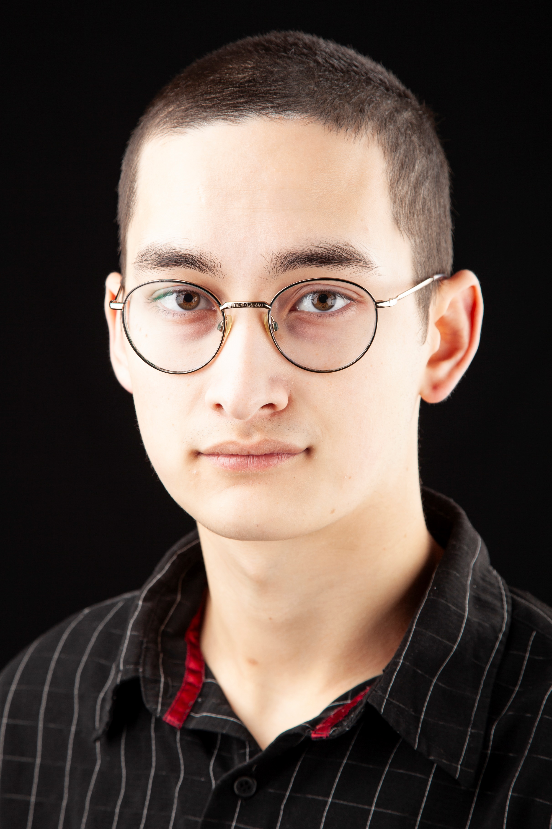
Email: l.swainson2003@gmail.com
Tel: 07815 423951

D.O.B: 23/01/2003 HEIGHT: 6ft 0 inches
EYES: Hazel HAIR: Black
EDUCATION: BA (Hons) Acting for Stage and Screen – Graduated 2024
SKILLS:
Accents & Dialects: (Native: Midlands) Scouse, RP, Scottish (Glaswegian), London (South, East End), West Country, American (General, Southern, East Coast, Valley), Irish (Southern).
Music & Dance: Singing (Bass/Baritone), Bass Guitar (Electric/Acoustic), Guitar (Electric/Acoustic), Alto Saxophone,
Sports: Proficient Swimmer, Rock Climbing, Competitive Running, Yoga.
Other Skills/Experience:
Trained chef, Stand-up Comedy, Frantic Assembly Workshop, Commedia Dell’Arte Workshops
CREDITS:
Role | Title of Piece | Director | Company | Type | Year
Entity | Chimera | Oscar W. Fitchett | George Kharsa-Thompson | Film | 2024
Sammy | The Boy and The Seahorse | Katy Weir | Squiggle Productions | Theatre | 2024
Caleb | MMXXIV | Oscar W. Fitchett | RNQ Productions | Film | 2024
The Clown | Tonight’s Entertainment | Luke Swainson | The Northern School of Art | Theatre | 2023
Ensemble | Metamorphoses | Peter Kerry-Forbes | The Northern School of Art | Theatre | 2023
Banquo | Macbeth | Jonathan Bussell | The Northern School of Art | Theatre | 2023
Ben | Making Your Acquaintance | Ella Patience | The Northern School of Art | Film | 2023
Unnamed | One Minute | Oscar W. Fitchett | RNQ Productions | Film | 2023
Cain | F.E.A.R | Rory Norton | The Northern School of Art | Film | 2022
Merlin | Stole the Show | Connor Dorrian | Trip Up North | Theatre | 2022
Ensemble | Love and Information | Katy Weir | The Northern School of Art | Theatre | 2022

