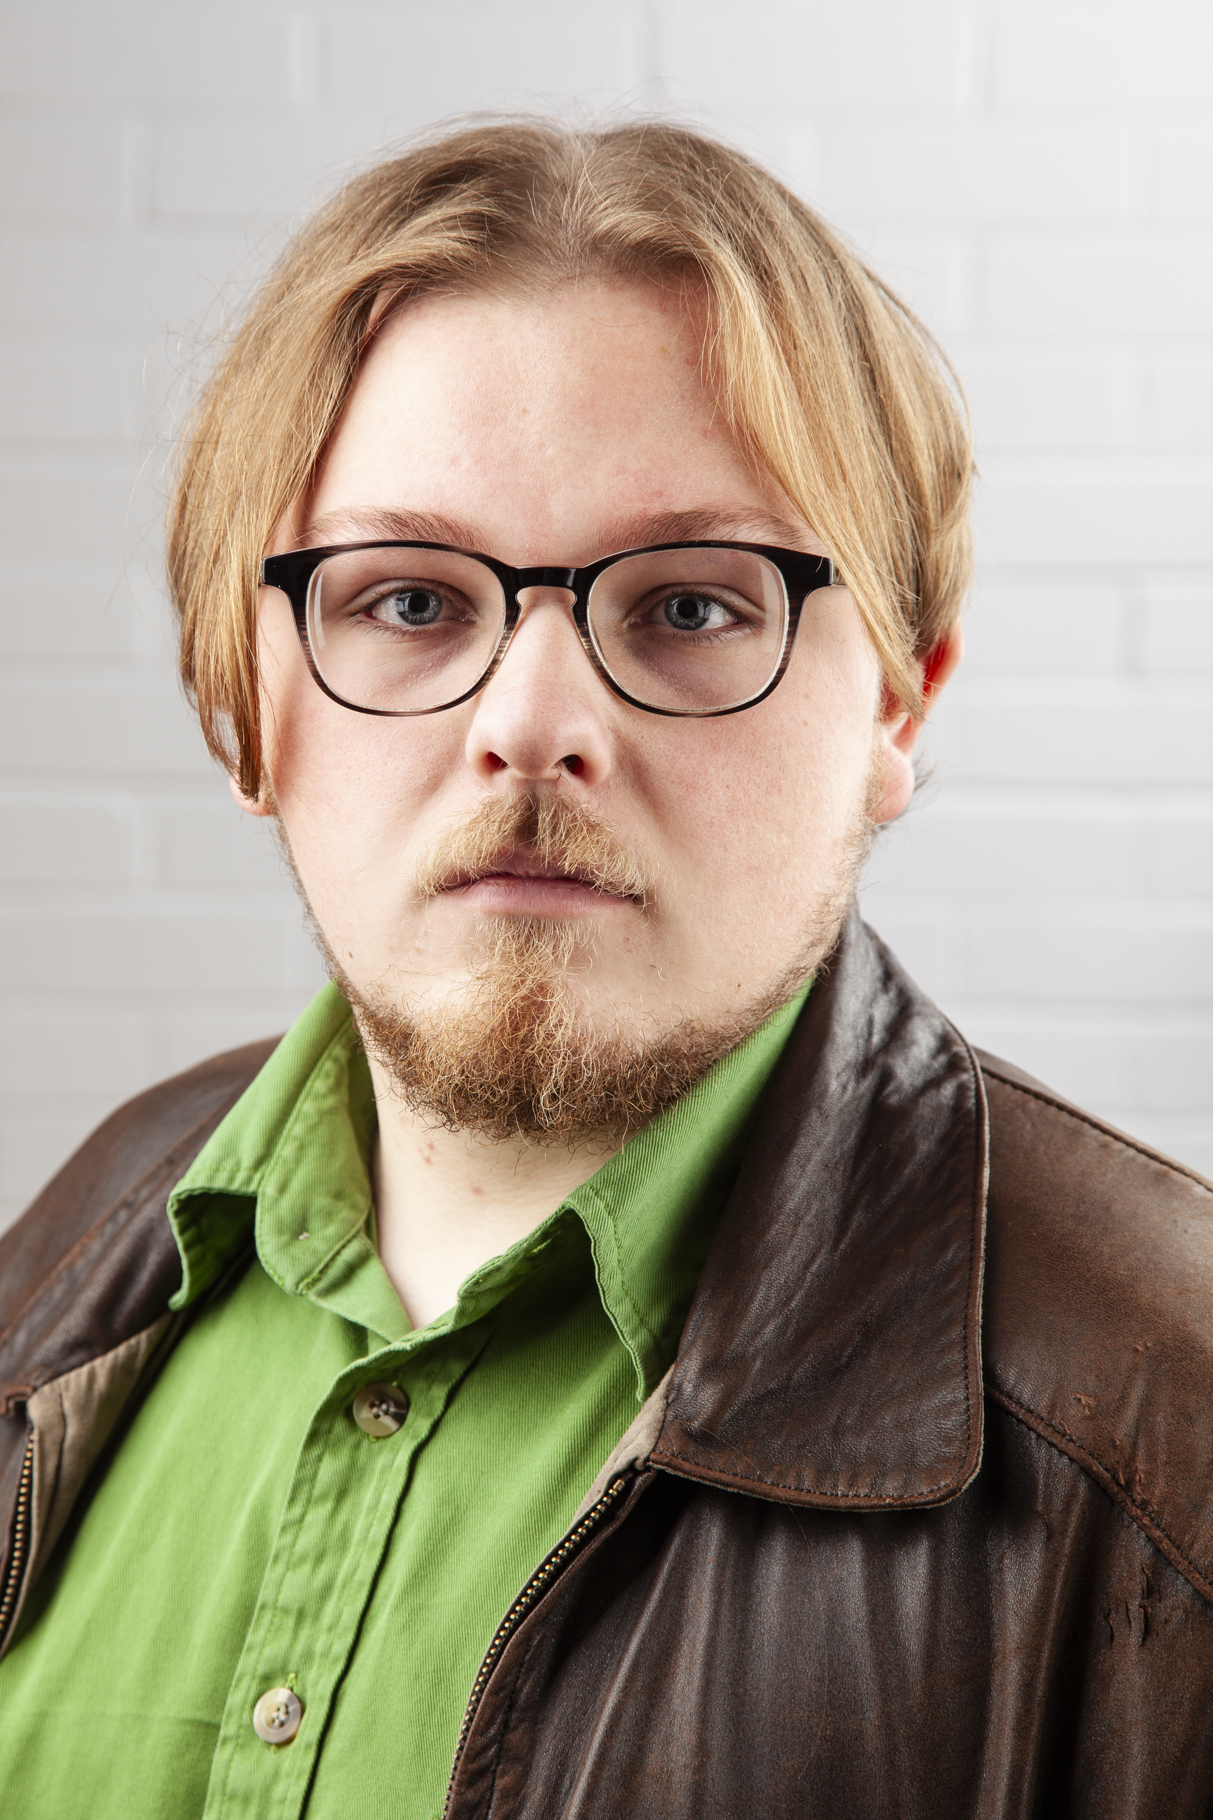
Luke Smith-Hogan
Email: lukesmithhogan@gmail.com
Tel: 07568789426
D.O.B: 24/04/2001 HEIGHT: 5,5
EYES: Blue HAIR: Blonde
EDUCATION: Northern School of Art (Graduate 2024)

SKILLS: Clowning, Voice Acting
Accents & Dialects: (Coventry), Birmingham, General American, RP
Sports: Boxing, football
Role | Title of Piece | Director | Company | Type | Year
Matt | Promise Me | Curtis Burnett | Green Lane Productions | Film | 2024
Angry space man | Angry space man | Luke Smith-Hogan | Northern School of art | Stage | 2023
Dylan | Brother Of Mine | Curtis Burnett | Green Lane Productions | Film | 2023
Multi Role | Metamorphosis | Peter Kerry-Forbes | Northern School Of art | Stage | 2023
Simple | Frame By Frame | Joe Casling | Northern School Of art | Film | 2023
Porter | Macbeth | Jonathan Bussell | Northern School of Art | Stage | 2023
Ben | As far as the eye can see | Sarah Webber | Northern School of Art | Film | 2023
Michael | Pretty Little Fears | Rory Norton | Green Lane Productions | Film | 2022
Multi role | Love and Information | Katie Weir | Northern School of Art | Stage | 2022
General | The lady from Maxim’s | David Edwards | Northern School of Art | Stage | 2022
Charlie Cheswick | One flew over the cuckoo’s nest | Katie McDonagh | Coventry College | Stage | 2021

