Izzy Spencer
Playing Age: 18-25
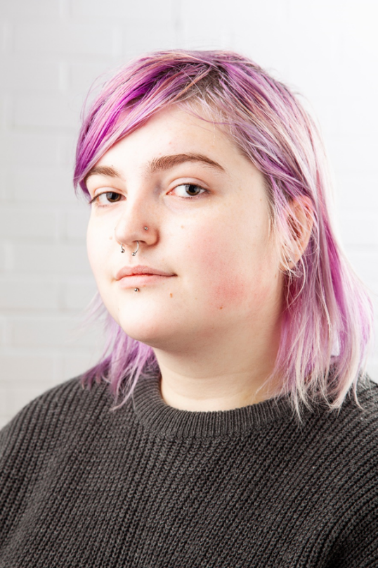
Height: 5’7
Email: Izzylilspencer@gmail.com
Natural hair: Brown
Eye: Hazel
Nationality: British

Training
New College Durham- BTEC L3 Extended Diploma Performing Arts/ Acting- Graduated 2021
Northern School of Art- BA Hons Acting for Stage and Screen- Ongoing

Theatre Credits
Production | Roles | Venue/Company | Director
The Lion, The Witch, and the Wardrobe | Grumpskin | New College Durham | Gemma Whelam
The Addams Family Musical | Uncle Fester/ Ensemble | New College Durham | Faye Cunningham
Love and Information | Ensemble | Northern School of Art | Katy Weir
The Haunting of Harrow House | Catherine Harrow | The Stockton Arc | Izzy Spencer, Sam Jolly, and Luke Swainson
Macbeth | Hecate/ Second Murderer/ Menteith | The Stockton Arc | Jonathan Bussell

Film Credits
Undercover Boss | Nikki Slowfish | Northern School of Art | David Edwards
The Last to Leave the Party | Sarah | Northern School of Art | Rachel Thomas

Skills
Accents: RP and Geordie.
Horse riding.
Devising.
Swimming.
Bike-riding.

