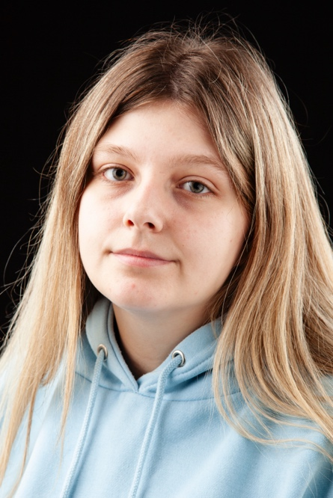
Name: Dion Brady
Email: Dion.brady07@gmail.com
Tel: 07538248366
D.O.B: 01/07/2003 HEIGHT: 5ft 8in
EYES: Green HAIR: Brown/Blonde
EDUCATION: The Northern School Of Art

SKILLS:
Accents & Dialects: Teesside (Native), RP
Other Skills/Experience:
Devising, script writing.
CREDITS:
Role | Title of Piece | Director | Company | Type | Year
‘The Plant’ | The Family | Niamh Henry & Hannah Trafford | Northern School of Art | Stage | 2024
Fairfield | We’ve Been Here Before | Luke Swainson | Northern School of Art | Stage | 2024
Charlie | Who Vandalised the School Library | Izzy Spencer | Northern School of Art | Radio | 2024
Britney | Second Life | Dion Brady, Luke Hogan, Shauna Coleman. | Northern School of Art | Stage | 2023
Charlie | Stay or go? | Dion Brady | Northern School of Art | Stage | 2023
Lady Macduff | Macbeth | Jonny Bussell | Northern School of Art | Stage | 2023
Ruby | Doctors | Rachel Thomas | Northern School of Art | Screen | 2023
Stevie | One Glass Away | David Michie | Northern School of Art | Screen | 2023

