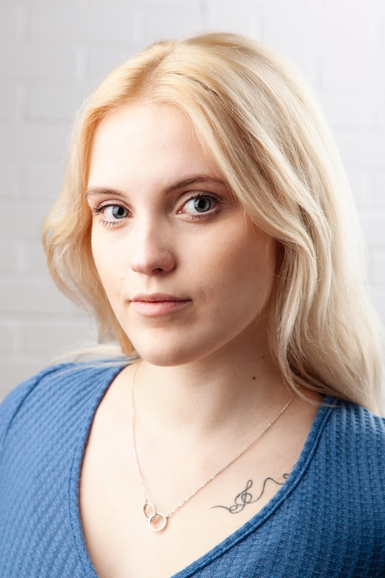
Ruby Allen
Email: ruby@groupallen.com
Tel: 07472737277

D.O.B: 17/12/2002 HEIGHT: 5”7
EYES: Blue HAIR: Blonde, long
EDUCATION: BA (hons) Acting for Stage and Screen at the Northern
School of Art

SKILLS: Full driving licence, musical theatre, devising, physical theatre, Clowning, Classical
Accents & Dialects: Northern Irish (Native), Southern Irish, General American, RP
Music & Dance: Singing (trained soprano up to grade 8), guitar, piano, trained minimal ballet, contemporary and jazz
Sports: Advanced Horse rider, yoga, acrobatics, pole dance
Other Skills/Experience: Comfortable being around and handling animals.

Role | Title of Piece | Director | Company | Type | Year
The Painter | Feel | Natasha Drymon | The Northern School of Art | Film | 2024
Lily | Flicker | Elen Bodey | The Northern School of Art | Film | 2024
The Mistress | The Family | Niamh Henry | The Northern School of Art | Stage | 2024
Chinley | We’ve been here before | Luke Swainson | The Northern School of Art | Stage | 2024
Tricia | MMXXIV | Oscar W. Fitchett | RNQ Films | Film | 2023
Emma | The Hobnob Crisis | Ruby Allen | The Northern School of Art | Stage | 2023
April | As Far as the Eye Can See | Sarah Webber and Eve Colpitts | The Northern School of Art | Film | 2023
Macduff | Macbeth | Jonathan Bussell | The Northern School of Art | Stage | 2023
Emma | Patiently Waiting | Rachel Thomas and Sian Finlan-Tuck | The Northern School of Art | Film | 2023
Liv | The Last to Leave the Party | Rachel Thomas | The Northern School of Art and Lonely Spaceman Productions | Film | 2023
Ensemble | Love and Information | Katy Weir | The Northern School of Art | Stage | 2022
Shrimp | The Lady from Maxime’s | David Edwards | The Northern School of Art | Stage | 2022

