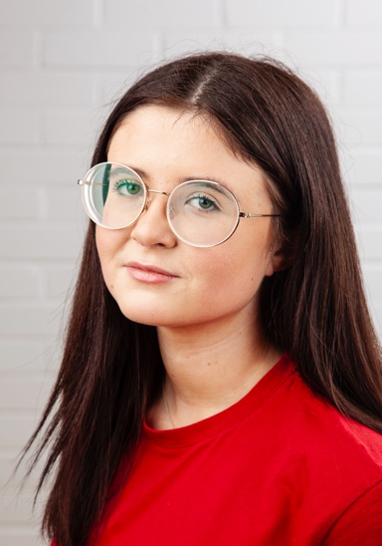
Name Becca Jayne
Email: Beccajayne200@gmail.com
Tel: 07931244166
D.O.B: 8th January 2003 HEIGHT: 5’2
EYES: Green HAIR: Mid length, dark brown
EDUCATION: BA (Hons) Acting for Stage & Screen at The Northern School of Art

SKILLS: Improvisation, Devising, Comedy, UK Driving Licence
Accents & Dialects: County Durham (Native), generalised Yorkshire, generalised Lancashire, RP.
Music & Dance: Singing, ukulele.
Other Skills/Experience: Clowning workshop.
Wrote, and performed a solo show at ARC Stockton.
CREDITS:
Role | Title of Piece | Director | Company | Type | Year
Leia | The Last Hurrah | Lucus McNally | NSA | Stage | 2024
Morgan | Truth/ Lie | Shauna Coleman | NSA | Stage | 2024
Sofia | Tonight’s the Night | Becca Jayne | NSA | Stage | 2023
Charlotte | Making Your Acquaintance | Ella Patience | NSA | Screen | 2023
Witch 3 Macbeth Jonathan Bussell NSA Stage 2023
Hope Patiently Waiting Rob Heselton NSA Screen 2023
Judith Wood ANT TV David Edwards NSA Screen 2022
Ensemble Love and Information Katy Weir NSA Stage 2022
Hannah One Glass Away David Michie NSA Screen 2022
V The Lady from Maxim’s David Edwards NSA Stage 2022

Pugsley Addams Family Faye Cunningham NCD Stage 2021
Addams The Musical

