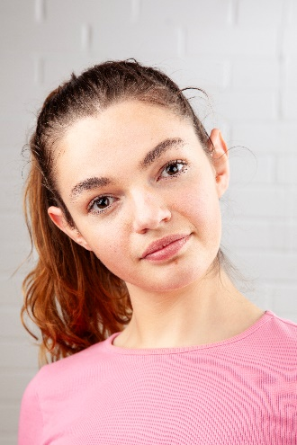
Darcey Dawson-Taylor

Email: darcey.dawsoncreative@gmail.com

Mobile number: 07842195464

D.O.B: 13/05/2003

Eyes: Hazel

Hair: Medium length, Brown

Education: Northern School of art - BA Hons Acting for Stage and Screen (Graduating 2024)

Location: Northeast/ East Midlands

Accents & Dialects: Derbyshire (Native), RP, General American, Northern, West Country, French

Music & Dance: Some dance training, choral singer

Sports: Football, Running, horse riding

Other Skills/Experience: Drama Facilitation at elderly homes, Drama facilitation in primary schools. Experience in puppetry and sensory theatre, fluent French speaker. CRB checked.

ROLE | TITLE OF PIECE | DIRECTOR | COMPANY | TYPE | YEAR
Hortentio | (Taming of) The Shrew | Multiple | Menstrual Rage | Stage | 2023
Sad Clown | Frame by Frame | Joseph Casling | Northern School of Art | Stage (with multi media) | 2023
Flashback Doctor | Patiently Waiting | Robert Heselton | Northern School of Art | Television | 2023
Lady Macbeth | Macbeth | Jonny Bussell | Northern School of Art (performed at the ARC, Stockton) | Stage | 2023
Jess | It’s Everyone’s Game | Hannah Trafford | Northern School of Art | Television | 2022
Amy | The Absence of Us | Natasha Drymon | Northern School of Art | Film | 2022
Various | Love and Information | Katy Weir | Northern School of Art | Stage | 2022
Etienne (Emily) | Lady from Maxim’s | David Edwards | Northern School of Art | Stage | 2022

