Shauna Coleman
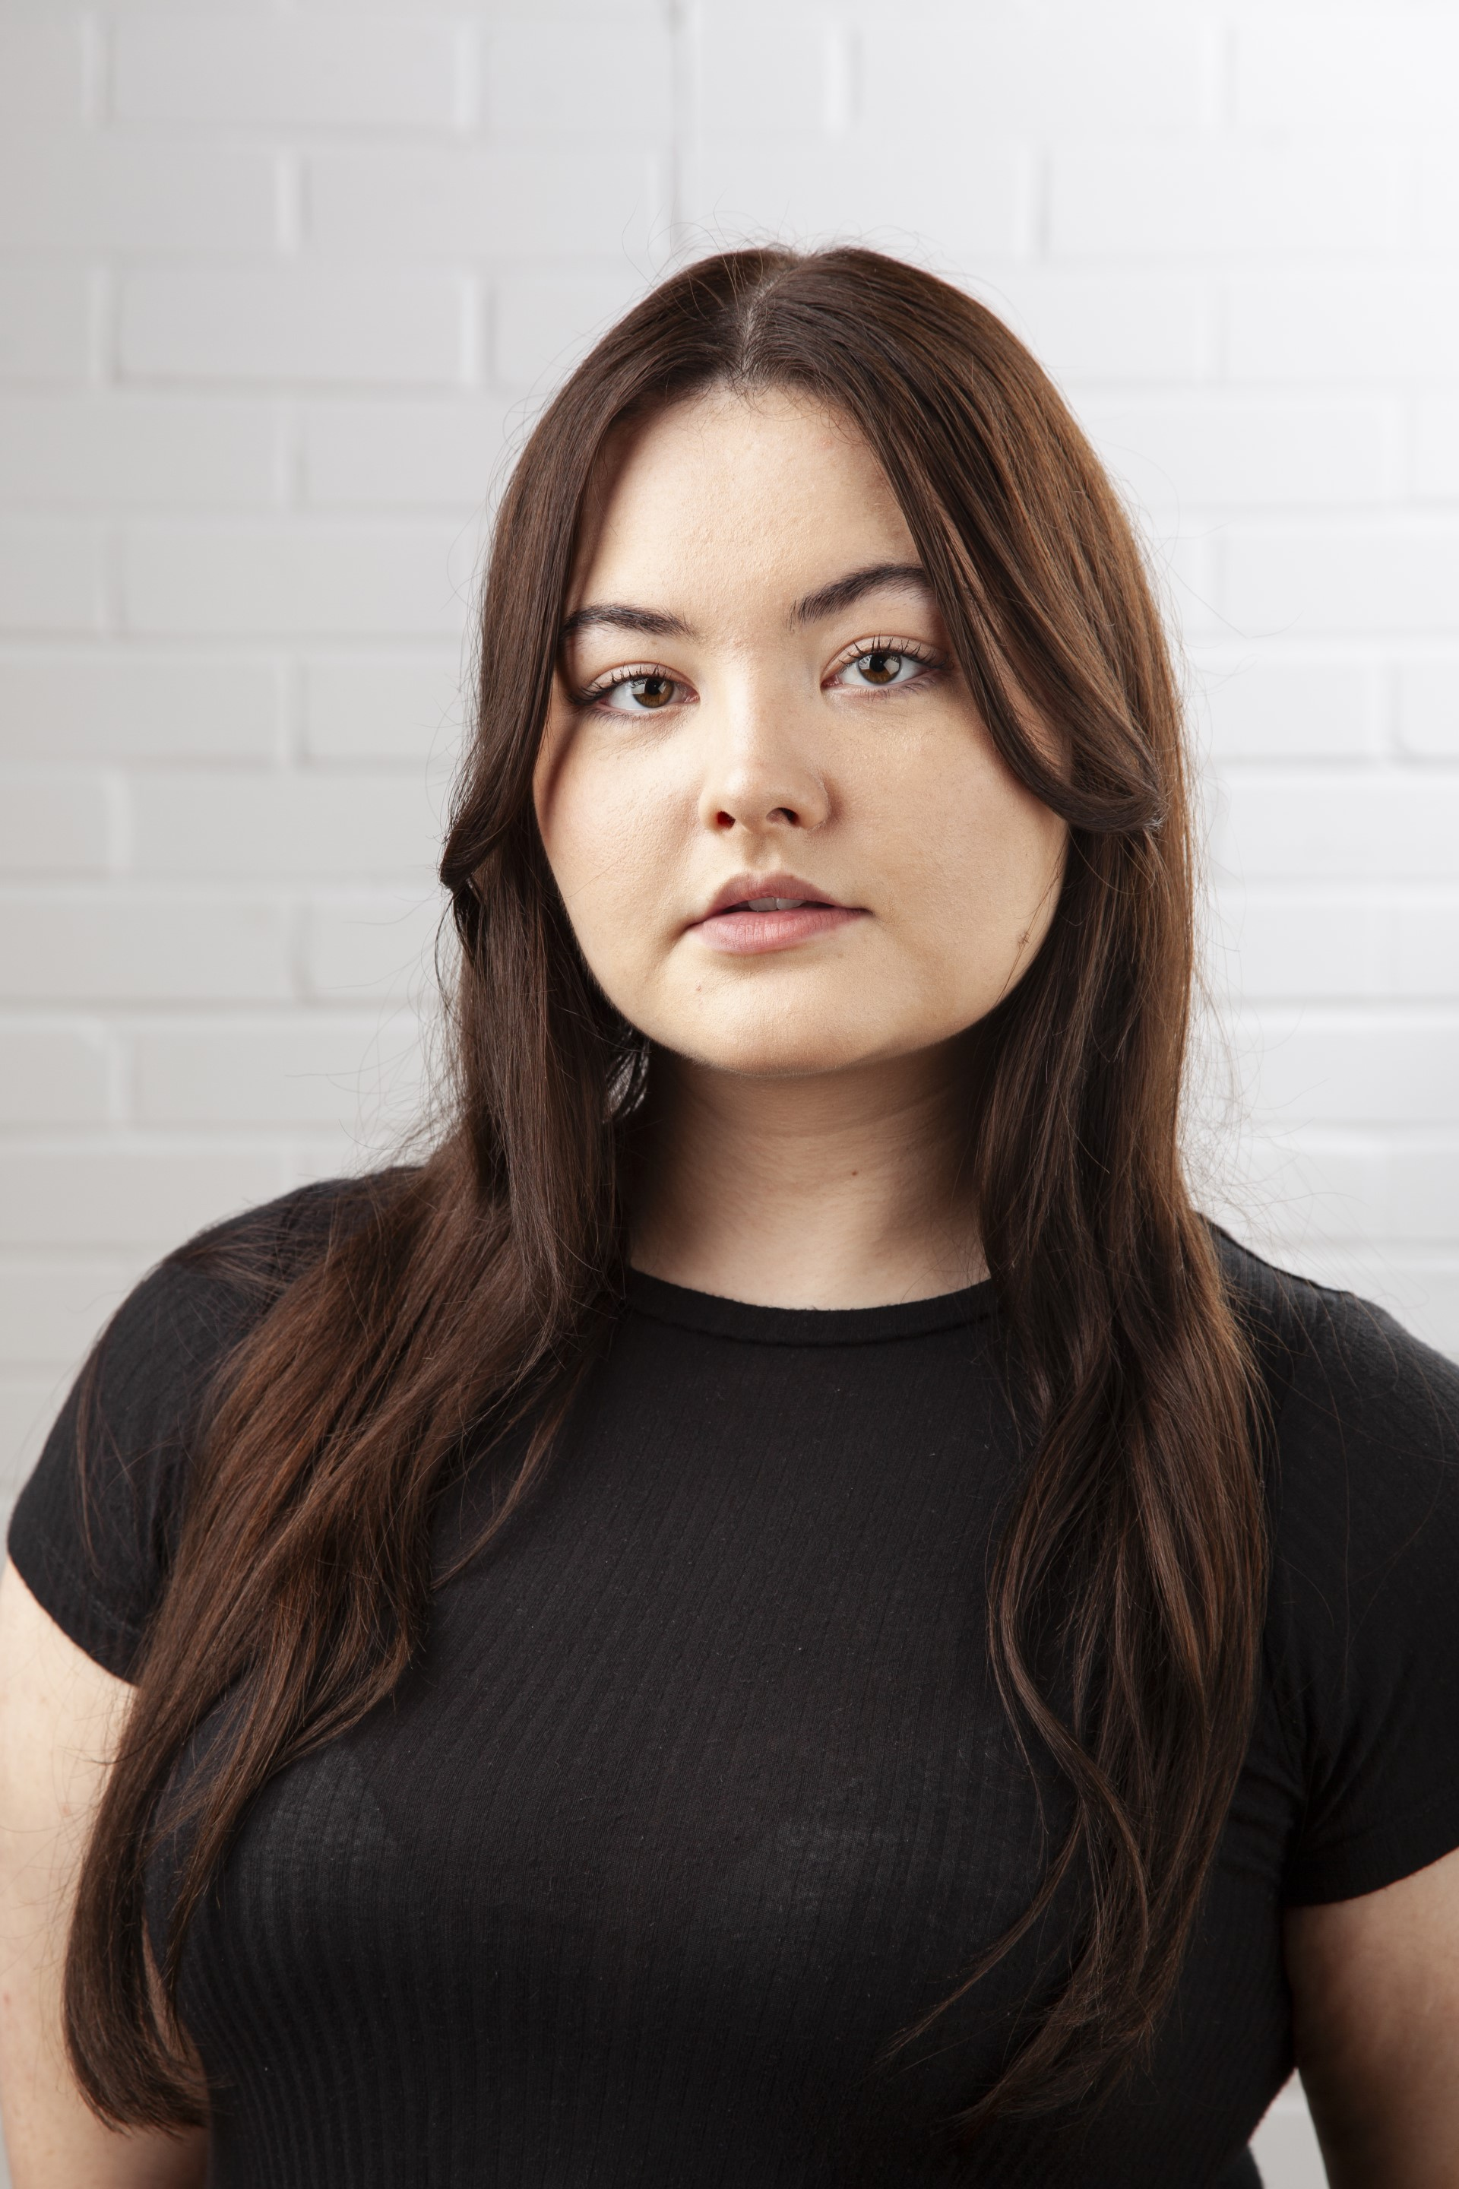
Email: shaunacoleman5884@gmail.com
Tel: 07368396507

D.O.B: 26/07/2003 HEIGHT: 5’4
EYES: Brown HAIR: Brown
EDUCATION: The Northern School of Art, Acting for Stage and Screen BA Hons
SKILLS:
Accents & Dialects: Yorkshire (Native), Received Pronunciation, General American, Cockney, Essex
Music & Dance: Soprano, Grade 8 Musical Theatre, Ballet (Grade Elementary), Tap (Grade Elementary), Modern (Grade Intermediate), Jazz (Grade 5) – All British Association of Teachers of Dancing grades (B.A.T.D)
Sports: Boxing, Basketball, Yoga, Swimming, Zumba
Other Skills/Experience: Writing, Directing, Clowning, Frantic Assembly workshop, Laban workshop, Clowning, Improvisation, Physical Theatre, Circus skills (Diabolo, plate spinning)
CREDITS:
Role | Title of Piece | Director | Company | Type | Year
Rosie | Promise Me? | Curtis J. Burnett | The Northern School of Art | Film | 2024
Jamie | Flicker | Elen Bodey | The Northern School of Art | Radio | 2024
1st Witch, 1st Murderer, Doctor | Macbeth | Jonny Bussell | The Northern School of Art | Stage | 2023
Emily  Sarah | Brother of Mine  Patiently Waiting | Curtis J. Burnett  Sian Finlan-Tuck | Greenlane Productions  The Northern School of Art | Film  Film | 2023  2023
Pea | Pip’s Fairyland Adventure | India Robertson | The Northern School of Art | Stage | 2023
Kathy Donaldson | ANT TV | David Edwards | The Northern School of Art | Film | 2022
Chelsea Windsor | Cocktails | Elizabeth Potter | The Northern School of Art | Film | 2022
Joan | Gone | Rob Heselton | Greenlane Productions | Film | 2022
Dancer | Mug | MAAD Productions | The Northern School of Art | Music Video | 2022
Ensemble | Love and Information | Katy Weir | The Northern School of Art | Stage | 2022
Clementine | The Lady from Maxim’s | David Edwards | The Northern School of Art | Stage | 2022

