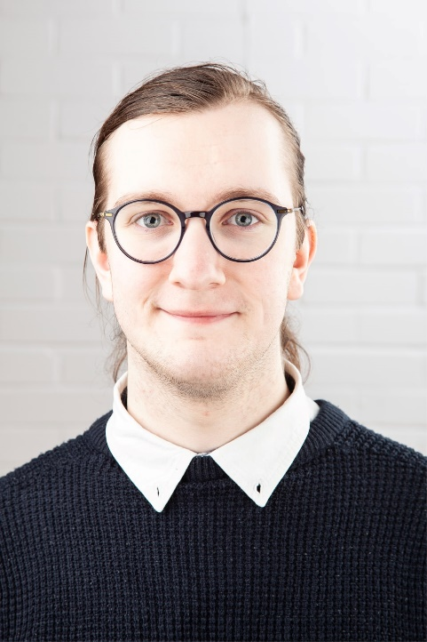
Luke Lawson
Email: lukelawson.acting@gmail.com
Tel: 07928 485516
D.O.B: 17/11/2002 HEIGHT: 5’10
EYES: Blue HAIR: Brown
EDUCATION:
BTEC Level 3 Extended Diploma – Performing Arts (Acting) @ New College Durham
BA (Hons) Acting for Stage and Screen @ The Northern School of Art
SKILLS:
Accents & Dialects: County Durham (Native), Received Pronunciation
Other Skills/Experience: Devising, Improvisation
CREDITS:
Role | Title of Piece | Director | Company | Type | Year
Higher One 3 | Feel | Natasha Drymon | The Northern School of Art | Short Film | 2024
Dylan | The Beast of Bolam Lake | Aaron Burns | The Northern School of Art | Short Film | 2024
Annoying Customer | Brother of Mine | Curtis J. Burnett | Green Lane Productions | Short Film | 2024
Ross | Macbeth | Jonathan Bussell | The Northern School of Art | Stage | 2023
Jamie | Patiently Waiting | Rob Heselton | The Northern School of Art | Television | 2023
Andrew | Gone | Rob Heselton | Green Lane Productions | Short Film | 2023
Brian Thornaby | Undercover Boss: ANT TV | David Edwards | The Northern School of Art | Television | 2023
Ensemble | Love and Information | Katy Weir | The Northern School of Art | Stage | 2022
Douglas | Gone | Rob Heselton | The Northern School of Art | Stage | 2022
The Priest | The Lady from Maxim’s | David Edwards | The Northern School of Art | Stage | 2022

