Name: Aaron Burton
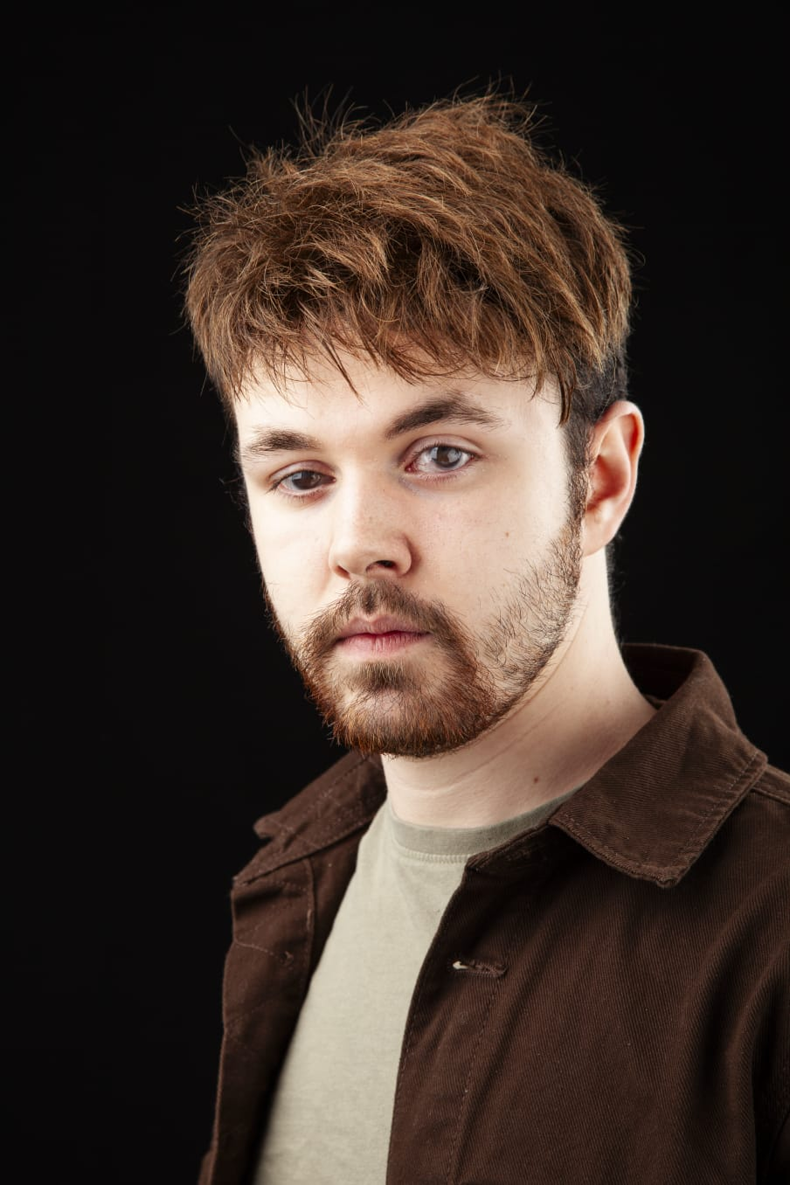
Email: aaronburton456@gmail.com
Tel: 07927730743
D.O.B: 11.5.01 HEiGHT:5ft 6 ½ EYES: brown HAIR: brunette
EDUCATION: BA {hons} acting for stage and screen {graduation 2024}
SKILLS:
Accents & Dialects: (Durham UK) R P, cockney, general American, Scottish.
Music & Dance: light lyric tenor, piano/keyboard.
Other Skills: organisation, good time management, can be a team player,
Experience: worked 2 weeks at Beamish Museum as an exhibitionist.
work experience at spark radio.
CREDITS:
Role |  | Title of Piece | Director |  | Company |  | Type | Year
Aperition  Multi role  Craig the currier  Multi role  Solider  Snork the porter |  | Macbeth  Macbeth  Doctors pilot  Love and information  Lady from Maxims  The elephant man | Jake Murray  Jonathan Bussell  Rachel Thomas  Katie weir  David Edwards  Clark Adamson |  | Elysium TC  The northern school of art  The northern school of art  The northern school of art  The northern school of art  Chester le street theatre group |  | stage  Stage  Film  stage  Stage  Stage | 2023  2023  2023  2022  2022  2019

