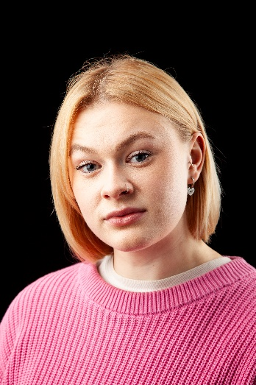
Elen Bodey
Email: elenbodey@yahoo.com
Tel: 07896925816
D.O.B: 21/03/1999 HEIGHT:5’5
EYES: Blue HAIR: Blonde
Education: BA (hons) Acting for stage and screen. The Northern school of Art.
Skills: Devising. Improvisation.
Accents & Dialects: Accent: Midlands.
Welsh (I know a basic amount and have learnt lines in the language for previous shows). General American. RP. Essex. Liverpudlian.
Sports: Hockey, football, swimming, running, cycling, basketball.
Other Skills/Experience: Barista coffee trained, full Uk drivers license, drawing, comfortable handling animals.
National youth theatre of Wales, Company 25, Story-house youth company, Laban workshop.
I had my own theatre company based in North Wales from 2018-2021, called Top Knotch Theatre.
CREDITS:
Role | Title of Piece | Director | Company | Type | Year
Max | Flicker | Elen Bodey | The Northern School of Art | Radio | 2024
Gabby | The Last Hurrah | Lucus McNally | The Northern School of art | Stage | 2024
Ray | Truth/Lie | Shauna Coleman | The Northern School of Art | Stage | 2024
Ensemble | Metamorphoses | Peter Kerry Forbes | The Northern School or Art | Stage | 2023
Daisy | Alone With you | Oscar W Fitchett | RNQ Films | Film | 2023
Malcolm | Macbeth | Jonathan Bussell | The Northern school of Art | Stage | 2023
Quinn | Patently Waiting | Rob Heselton | The Northern School or Art | TV | 2023
Sophia | Making your Acquaintance | Ella Patience | The Northern School or Art | Film | 2023
Ash | The Last to Leave the Party | Rachel Thomas | The Northern school of Art | Film | 2022
Gabrielle | The Lady from Maxims | David Edwards | The Northern school of Art | Stage | 2022
Roland and Marianne | Constellations | Elen Bodey | Top Knotch Theatre | Stage | 2021
Mr. Toad | The Wind in the Willows | Elen Bodey | Top Knotch Theatre | Stage | 2019

