Art & Design Lecturer (Interior, Architecture and Production Design)
Permanent
17.5 hours per week
Annual Salary - £15,046 - £18,179 (FTE £30,093-£36,358)
based on increments, progression only if teacher qualified)
Start Date: ASAP

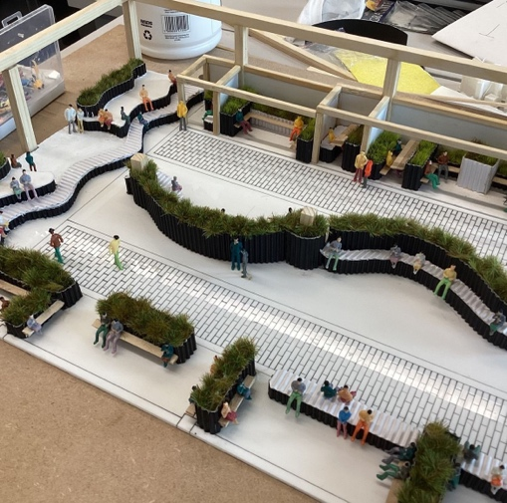 | 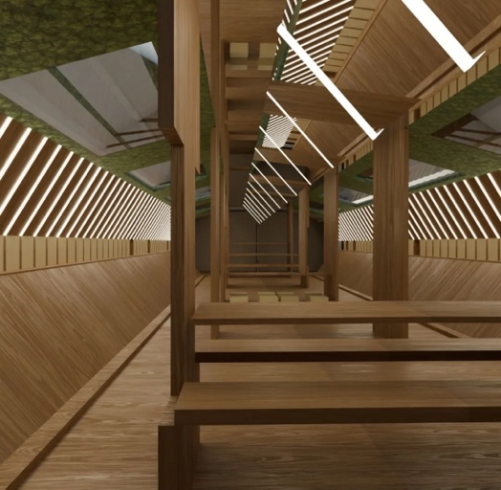 | 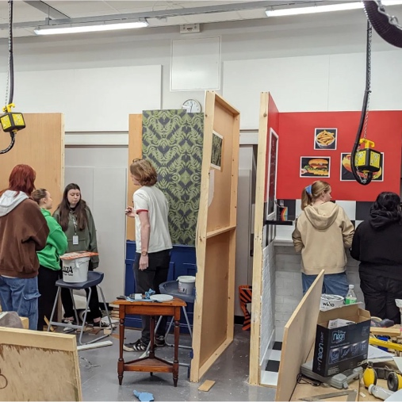

In September 2021 we moved to our brand new building in the centre of Middlesbrough. We are looking for a high calibre Lecturer who has 3D and Digital Design skills, but someone who is also flexible to cover within different areas of Art & Design courses and therefore a strong drawing and design skillset is essential. The postholder will assist the Cluster Leader in the delivery of courses, ensuring a high quality of teaching and learning for students and effective student achievement and progression.

You must be able to inspire and enthuse students about the subject and make the subject interesting, lively and accessible to all through your innovative delivery of the curriculum.

The ideal candidate will also have a creative art and design background and have an Honours degree (or equivalent) or exempting professional experience, with a professional portfolio of work.

What will you get if you join us?
- The opportunity to work in an OFSTED Outstanding, award-winning institution with creative people in a creative environment, where the exchange of ideas is integrated into the work ethic
- The knowledge that you have a positive impact on the development of students and the choices they make in life.
- Support and guidance in making any difficult decisions to achieve the targets you have been set.
- Access to personal skills development to help you achieve your targets and your longer term career goals.
- Access to the Teachers’ Pension scheme (with significant employer contributions).

PLEASE SEND YOUR DIGITIAL PORTFOLIO WITH YOUR APPLICATION FORM
Closing date for receipt of completed application forms: 11 August 2024

If selected, interviews will be held on 20th August 2024, we will endeavour to
inform selected candidates by 13th August 2024.

To download the application pack please go to our website - https://northernart.ac.uk/careers/
All completed applications should be emailed to jobs@northernart.ac.uk

