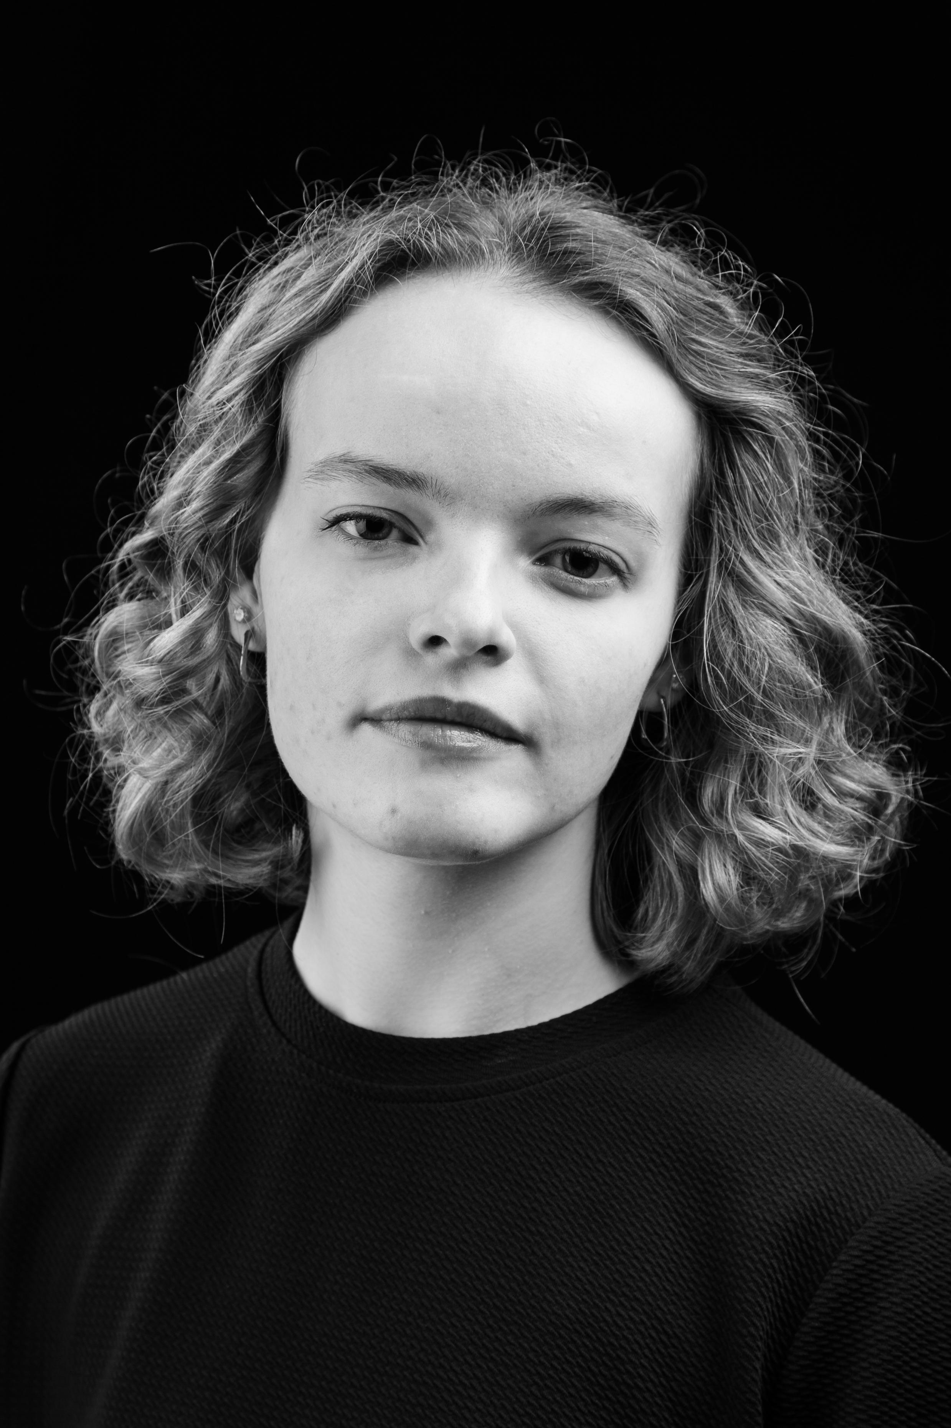**Kate Hann**

**Height:** 5ft 1” **Eyes:** Blue

**Hair:** Dark Blonde, naturally curly

**Date of Birth:** 09 Aug 2004

**Training:** Wansbeck Performing Arts Academy

**Education:** BA (Hons) Acting for Stage and Screen

The Northern School of Art

**Accent:** Geordie, Northumberland (native)

**Skills:** Grade 5 ballet, Grade 5 tap, basic roller-skating

**Credits:**

|  |  |  |  |  |  |
| --- | --- | --- | --- | --- | --- |
| Role | Production | Director | Company | Type | Year |
| Ann Putnam  Giles Corey | The Crucible | Katy Weir | Northern School of Art | Stage | 2025 |
| Maria | Current Sea | Jess Sample | Northern School of Art | Stage | 2024 |
| Cassius | Julius Caesar | Jonny Bussell | Northern School of Art | Stage | 2024 |
| Chloe | Beast of Bolam Lake | Aaron Burns | Northern School of Art | Short Film | 2024 |
| Jessica | Tender | David Edwards | Northern School of Art | Short Film | 2024 |
| Ruth | Blithe Spirit | Tony Chapman | Newcastle College University Centre | Stage | 2023 |
| Performer | Toys Are Back In Town | Andrew Stead | Wansbeck Performing Arts | Gig | 2022 |
| Stage Management  Training | Hamlet + Love’s Labour’s Lost | Corinne Kilvington | Theatre Space | Outdoor Theatre | 2022 |
| Estella | Great Expectations | Jessica Atkinson | Newcastle College | Stage | 2022 |
| Wadsworth | Clue | Andrew Stead | Wansbeck Performing Arts | Stage | 2021 |

Email: [katehann22@gmail.com](mailto:katehann22@gmail.com)

Tel: 07512 579936