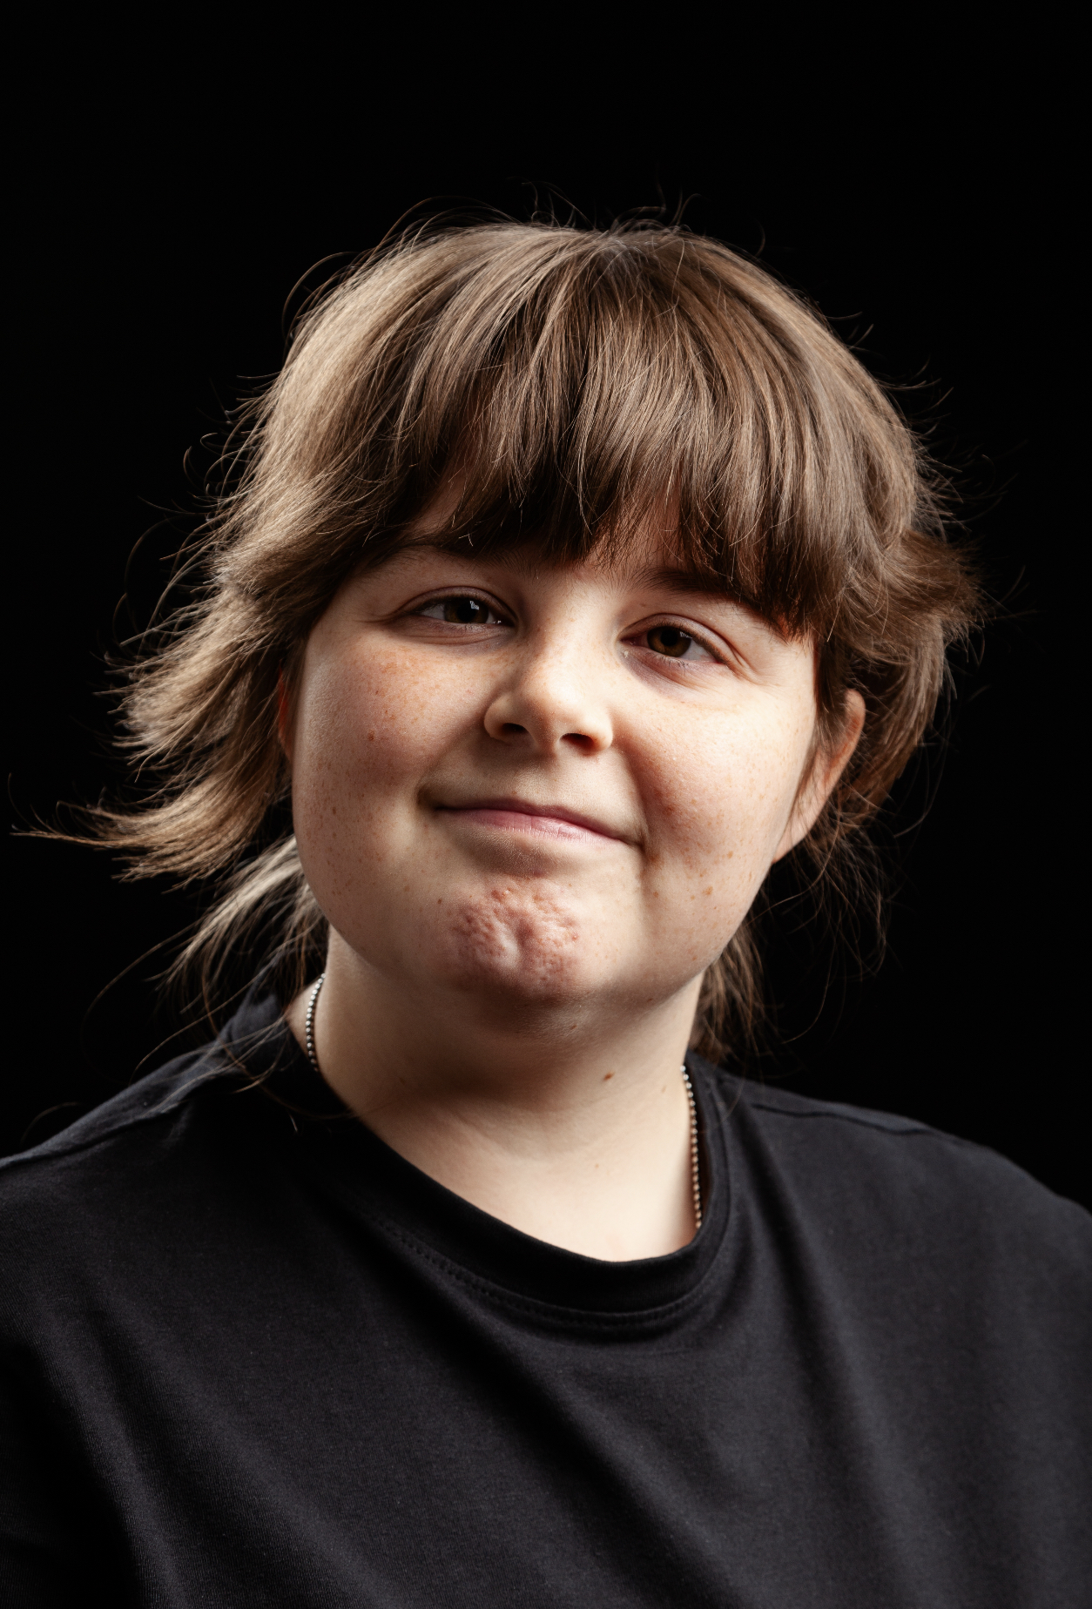Megan Dale

|  |
| --- |
| **Email: megan.dale1@icloud.com**  **Tel: 07723372557** |

**D.O.B:** 26/04/2004 **HEIGHT: 5’4**

**EYES:**  brown  **HAIR: brown**

**EDUCATION: BA Hons Acting for Stage & Screen – Graduation 2025**

**SKILLS:**

***Accents & Dialects:*** Teeside *(Native), Generic American.*

**CREDITS:**

|  |  |  |  |  |  |  |
| --- | --- | --- | --- | --- | --- | --- |
|  |  |  |  |  |  | |
| **Role** | **Title of Piece** | **Director** | **Company** | **Type** | **Year** |
| Multiple | The Tavern | Megan | Northern School of Art | Stage | 2024 | |
| March Hare | Hullabaloo in Womderland | Stan Hodgson | Theatre Hullabaloo | Outdoor theatre | 2024 | |
| Grandmother | Nevermore | Paige Dyson | Northern School of Art | Stage | 2025 | |
| Multiple | The Lady & The Jester | Zoe Hudson | Northern School of Art | Stage | 2025 | |
| Annoying | Tender | David Edwards | Northern School of Art | Short Film | 2024 | |
| Multiple | Julius Caesar | Jonathan Bussell | The Arc | Stage | 2024 | |
| Multiple | There is a War | David Edwards | Northern School of Art | Stage | 2023 | |
| Multiple | Grimm’s Tale | Katy Weir | Northern School of Art | Stage | 2023 | |