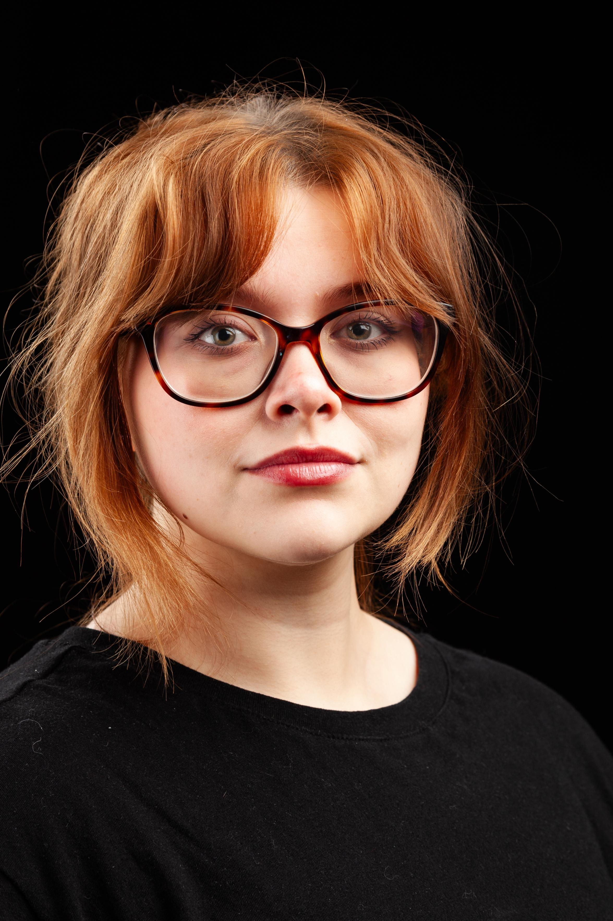Paige Dyson

|  |
| --- |
| **Email:** [**Dyson.paige456@gmail.com**](mailto:Dyson.paige456@gmail.com)  **Tel: +447737139650** |

**D.O.B:** 07.11.2000 **HEIGHT:** 5”4

**EYES:**  Green  **HAIR:** Auburn,Medium Length

**EDUCATION:** BA (Hons) Acting For Stage and Screen, Northern School Of Art

**SKILLS:**

***Accents & Dialects:*** Durham *(Native)* RP, Valley girl, Standard American, Geordie, Heightened RP.

***Music & Dance:*** Singing – Alto.

***Sports:***

**Other Skills/Experience:** Basic Aerial Hoop, voice acting, Audio Drama.

**CREDITS:**

|  |  |  |  |  |  |
| --- | --- | --- | --- | --- | --- |
| **Role**  Phillipa  Abigail Williams | **Title of Piece**  Fruit Shaken From The Tree  The Crucible | **Director**  Georgia Purvis  Katy Weir | **Company**  Northern School Of Art  Northern School Of Art | **Type**  Radio  Stage | **Year**  2025  2025 |
| Juniper | Anthology of Reveries | Emily Jeffery | Northern School Of Art | Short Film | 2025 |
| Portia | Julius Caesar | Jonathan Bussell | Northern School Of Art | Stage | 2024 |
| MJ (Mary-Jane) | Tender | David Edwards | Northern School Of Art | Short Film | 2024 |
| Luke | There is a War | David Edwards | Northern School Of Art | Stage | 2023 |
| Lily | Lily’s and Lavenders | Liv Wind | Northern School Of Art | Stage | 2023 |
| Aspen | Faeries Fable | Emily Jeffery | Northern School Of Art | Short Film | 2022 |
| Multi-role | Grimm’s Fairy tales. | Katie Weir | Northern School Of Art | Stage | 2022 |