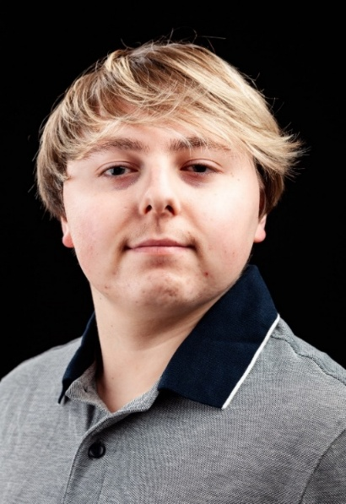Tai Peters

|  |
| --- |
| **Email:** taipeters@outlook.com  **Tel:** 017912 627779 |

**D.O.B:** 17/04/2003 **HEIGHT:** 5’2

**EYES:**  Blue  **HAIR:** Bleached highlights

**EDUCATION:** BA (Hons) Acting for Stage & Screen

***Accents & Dialects:*** (*Hertfordshire Native),* Standard Australian, Standard Scottish, Standard Southern Irish, Standard American

**SKILLS:** Provisional Driver, Basic Guitar, Basic Bass, Basic Keyboard, Judo Green Belt

**CREDITS:**

|  |  |  |  |  |  |
| --- | --- | --- | --- | --- | --- |
| **Role** | **Title of Piece** | **Director** | **Company** | **Type** | **Year** |
| Ezekiel Cheever | The Crucible | Katy Weir | The Northern Art | Stage | 2025 |
| Fok | The Lady & The Jester | Zoe Hudson | The Arc | Stage | 2025 |
| Hugo | Fruit Shaken from the Tree | Georgia Purvis | The Northern Art | Radio | 2025 |
| Reggie | Implosion | Shaun Wilson | The Arc | Stage | 2025 |
| Dopey | Tender | David Edwards | The Northern Art | Short Film | 2024 |
| Multiple | Julius Caesar | Jonathan Bussell | The Arc | Stage | 2024 |
| Multiple | There Is A War | David Edwards | The Northern Art | Stage | 2023 |
| Multiple | Grimm’s Tales | Katy Weir | The Northern Art | Stage | 2023 |
| Captain Flint/Badger | Treasure Island | Shannon France | York College | Stage | 2022 |
| Chorus | Humpty Dumpty | Luke Arnold | The Kirk Theatre | Stage | 2020 |