Tia Lily
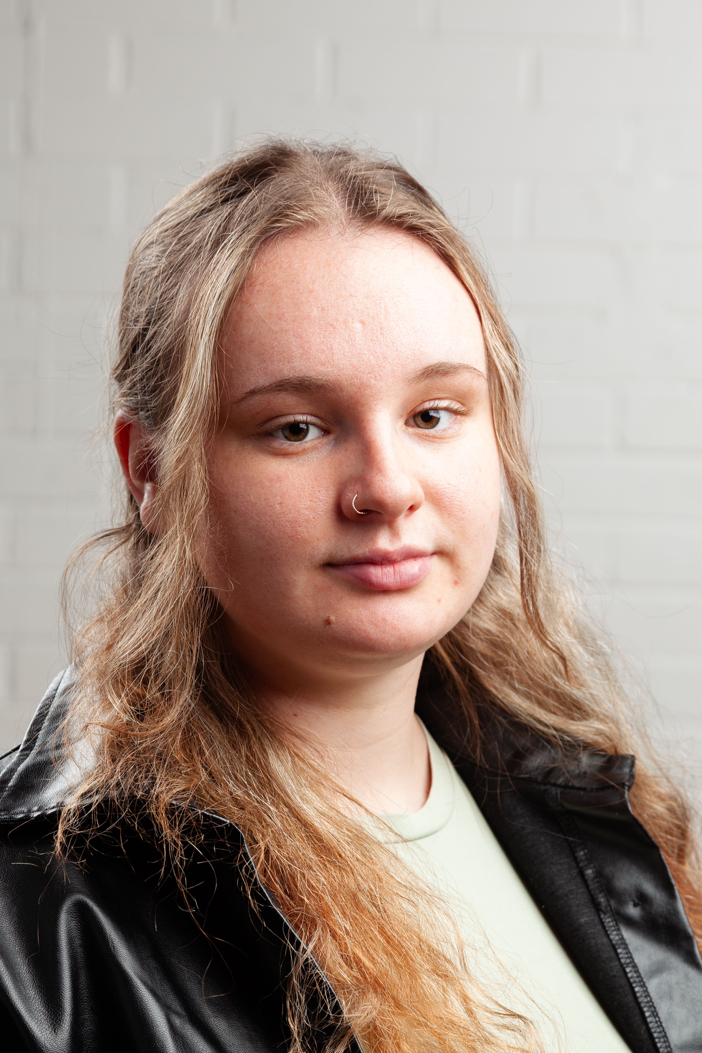
Email: tiannaprestonnorth@gmail.com
Tel: 07591916911

D.O.B: 02/07/2004 HEIGHT: 5ft 5.
EYES: hazel HAIR: mid blonde,long
EDUCATION: BA (Hons) Acting for Stage and Screen @ The Northern School of Art, Hull Truck Youth Theatre.
SKILLS: Devising, baby cry, balloon modelling, comedy, clowning, writing, baking, pyrography, voice acting.
Accents & Dialects: Hull (Native), General Yorkshire, General American, General Australian.
CREDITS:
Role | Title of the piece | director | company | type | year
ANNe | Nevermore | Paige Dyson | ARC Stockton | Stage | 2025
Pippa | Nose to Nose | Public Nuisance | ARC Stockton | Stage | 2025
Mary warren | The Crucible | Katy Weir | ARC Stockton | stage | 2025
Lucy | Sorry reflections | Tia Lily | ARC Stockton | Solo show | 2024
Multiple characters | Caesar | Jonathan Bussell | ARC Stockton | Stage | 2024
Ms Daly | Tender | Dr David Edwards | The Northern School of Art | Short film | 2024
woman | Medea Redux | Eve Robertson | John Marley Center | Solo show | 2023
Multiple characters | There Is A War | Dr David Edwards | The Northern School of Art | stage | 2023
Multiple characters | Grimms Tales | Katy Weir | The Northern School of Art | Stage | 2022
Multiple characters | TEN | Tom Saunders | Hull Truck Theatre | Stage | 2019

