Jade Osborne
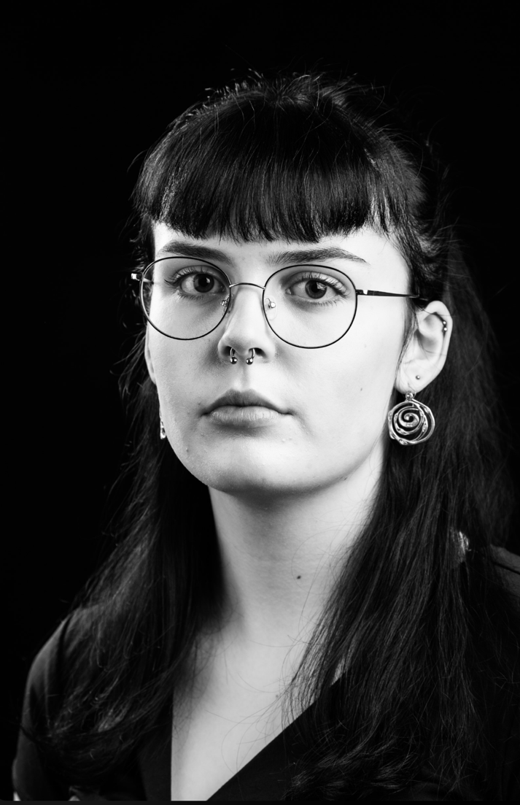
D.O.B: 06/07/2005 HEIGHT: 5,9
EYES: Brown HAIR: Black
EDUCATION: BA (Hons) Acting for Stage and Screen at The Northern School of Art (Graduating 2026)
SKILLS: Running, cycling, beginner bass player, crochet, knitting
Accents & Dialects: Geordie accent (Native), Southern American, RP.
Music & Dance: Alto singing voice, basic dance knowledge.

CREDITS:
Role | Title of Piece | Director | Company | Type | Year
Emily  Actor/Bank  Mandy | Girls will be Girls  My Mother's Funeral  First Dates | Jade Osborne and Cameron Thompson  Jonathan Bussell  Jonathan Bussell | The Northern school of Art  The Northern school of Art  The Northern school of Art | Stage  Stage  Film | 2026  2026  2026
Sam | An Eye for an Eye | Josh Prudence | The Northern school of Art | Radio play | 2026
Banquet guest | Ghost Train | Bill Palmer and Chris Squire | Walk the Plank | Stage | 2025
Narrator | A tail for our Future | Elen Bodey | The Northern school of Art | Stage | 2025
Quintus | Titus Andronicus | Dr David Edwards | The Northern school of Art | Stage | 2025
Rebecca | The Empty Bliss | Jade Osborne, Pierre Brown, Freya Reid, Theresa Maggs and Ella Hand. | The Northern school of Art | Stage | 2025
Aegisthus | Elektra | Lucus McNally | The Northern school of Art | Stage | 2025
Zoe/Lady Joan of Wales/Bleithwn | Lonely murders for lonely women | Jade Osborne, Pierre Brown, Millie Maxwell, Faye Atkinson, and Josh Prudence. | The Northern school of Art | Radio play | 2025
Katie | Actualities | Curtis Burnett | The Northern school of Art | Screen | 2024
Sadie | The four campers | Owen Burke | The Northern school of Art | Screen | 2024
Priest/ Servant | The Outsider | Dr David Edwards | The Northern school of Art | Stage | 2024
Protestor 1/Nurse | No Particular order | Jonathan Bussell | The Northern school of Art | Stage | 2024
Jenny | Troubled | Owen Burke | The Northern school of Art | Screen | 2024

