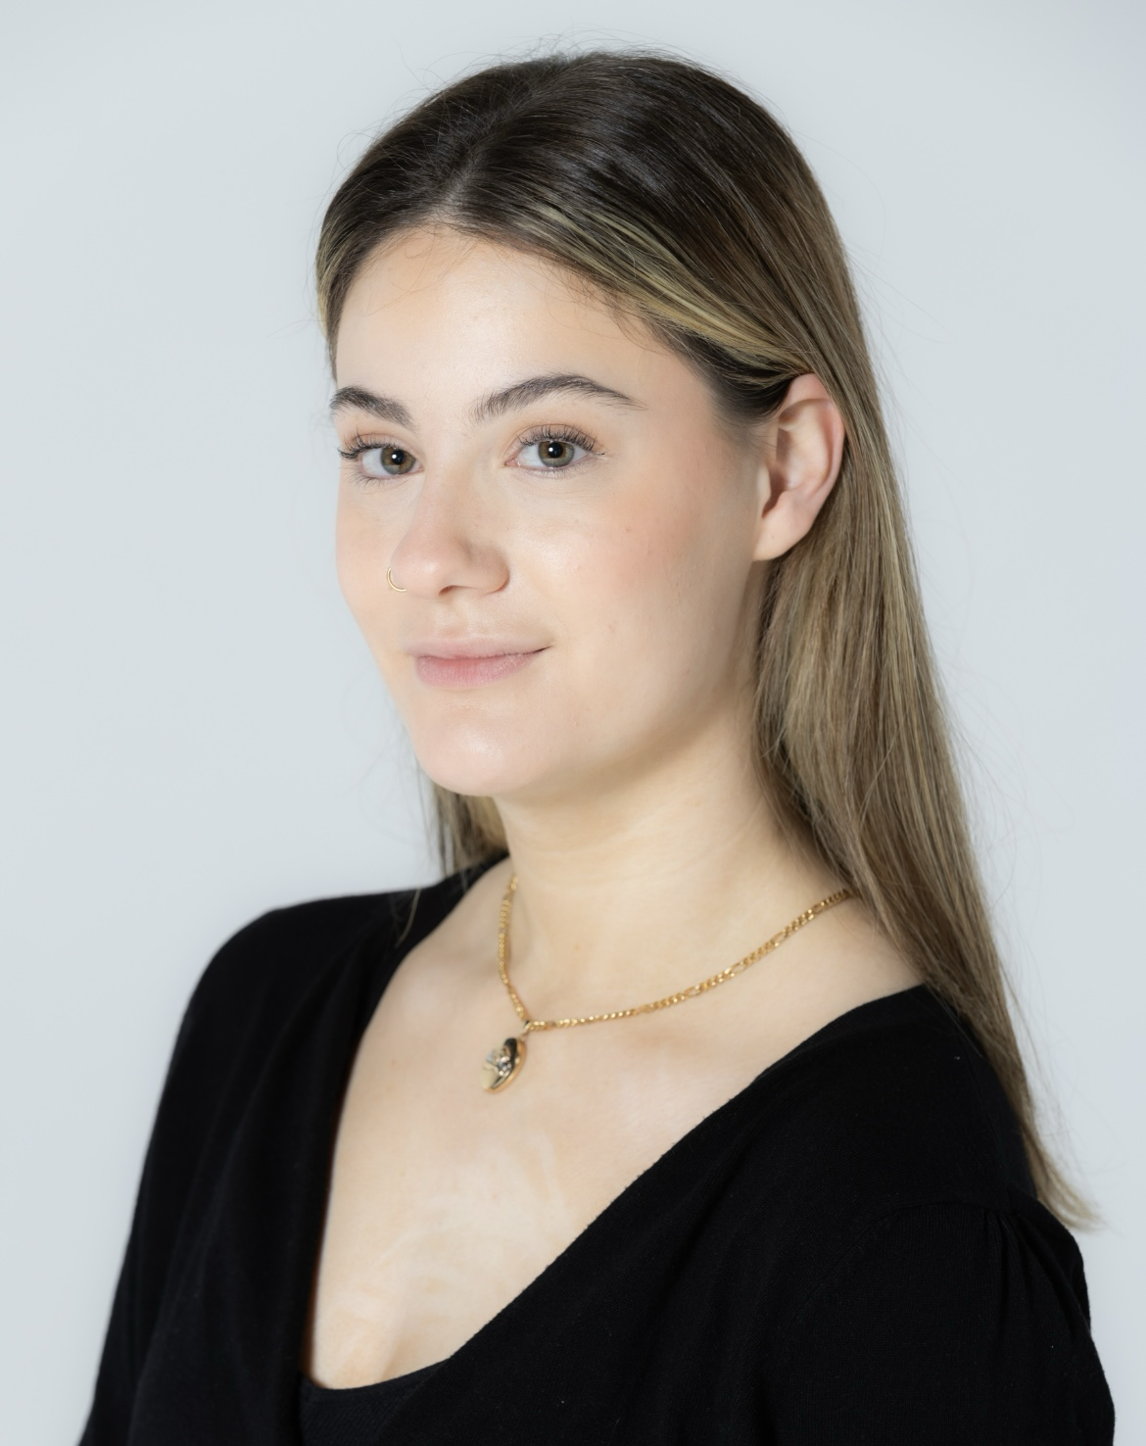
Chloe Rattigan
Email: chloe.rattigan293@icloud.com
Tel: 07455059807
Showreel Footage: https://youtu.be/5NBs4eJ6770?feature=shared

D.O.B: 29/03/2005 HEIGHT: 5’7
EYES: Hazel HAIR: Brunette
EDUCATION: BA (Hons) Acting for Stage and Screen at The Northern School of Art. (Graduation- 2026)

SKILLS:
Accents & Dialects: Yorkshire (Native), American (Californian), RP.
Music & Dance: Modern dance, Contemporary dance, Ballet, Pointe (beginner) Tap, Jazz, Musical Theatre (up to grade 6), Intermediate singing skill.
Sports: Dance.
Other Skills/Experience: Modeling, Teaching, Driving, Cycling.
CREDITS:

Role | Title of piece | Director | Company | Type | Year
Lily | Just Another Chapter | Alex Jade Wallace | Northern School of Art | Stage | 2025
Young Lucius | Titus Andronicus | Dr. David Edwards | Norther School of Art | Stage | 2025
Cassie | Seventeen | Devised | Northern School of Art | Stage | 2025
Presenter/  Mum | Guide to Girlhood | Devised | Northern School of Art | Radio | 2024
Arabella | Actualities | Curtis J. Burnett | Northern School of Art | Screen | 2024
Storyteller | Hullaballoo in Wonderland | Stan Hodgeson | Hullaballoo | Site Specific | 2024
Mother | The Outsider | Dr David Edwards | Northern School of Art | Stage | 2024
Female Soldier | No Particular Order | Jonathan Bussell | Northern School of Art | Stage | 2024
Megan | Bridesmaids | Dr David Edwards | Northern School of Art | Screen | 2023
Sarah | The Sad Club | Alice Kynman | Stephen Joseph Theatre | Stage | 2023

