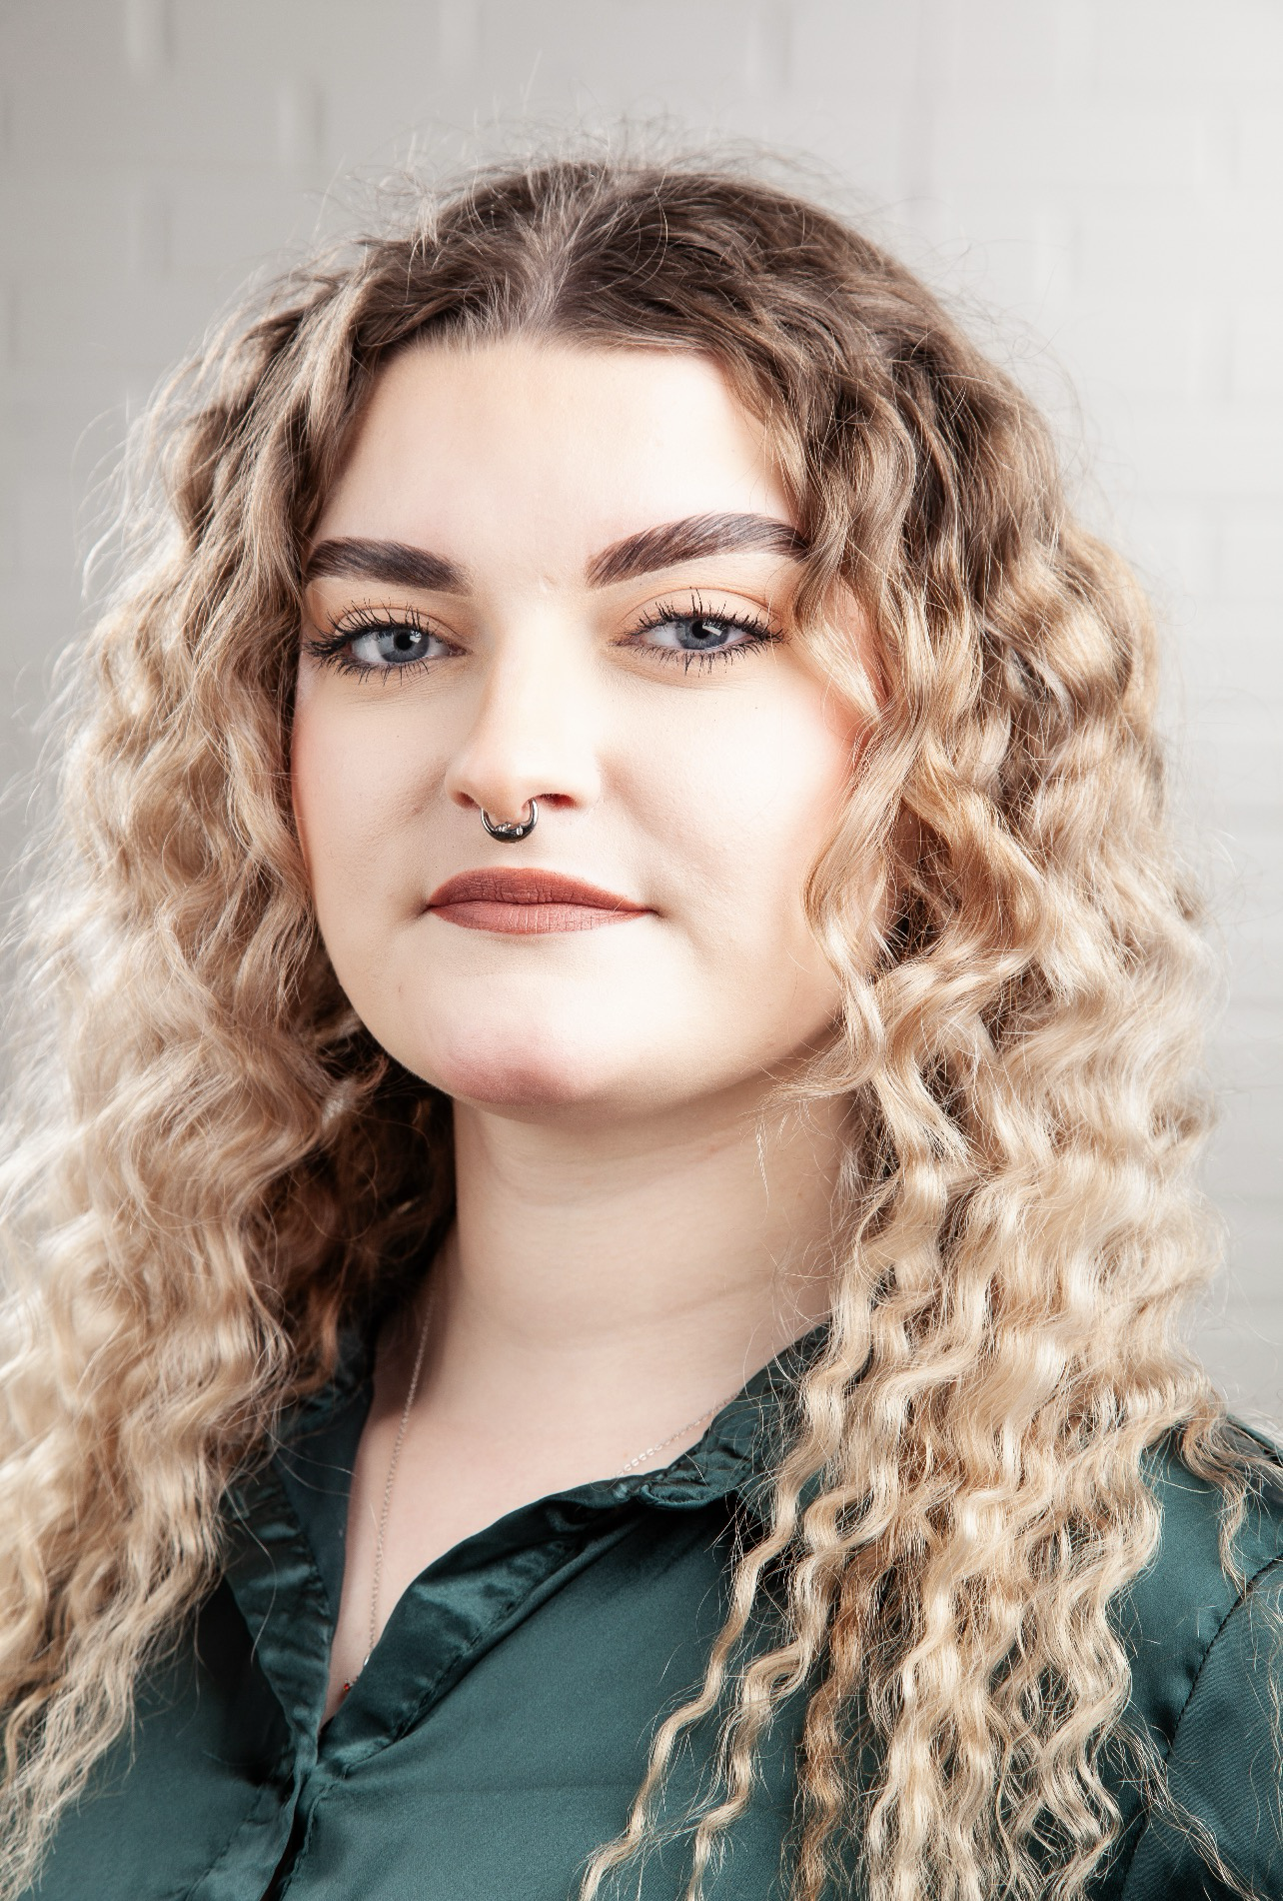
Name: Molly McKean
D.O.B: 07/03/2005 HEIGHT: 5”8
EYES: Blue HAIR: Blonde
EDUCATION: BA (HONS) Acting for Stage and Screen at The Northern School of Art (Graduation year 2026)
SKILLS:
Accents & Dialects: Hull (Native), Yorkshire, RP,
Music & Dance: Alto voice, singing genres: Jazz, Musical Theatre and Contemporary Pop and Country
Other Skills/Experience: Makeup, Bar work, Modelling, Cycling, Singing.

CREDITS:
Role | Title of Piece | Director | Company | Type | Year
Alma | Black Teeth and a Brilliant Smile | Steve Byron | The Northern School of Art | Stage | 2026
Martius | Titus Andronicus | David Edwards | The Northern School of Art | Stage | 2025
Ava Rowntree | Solivagant | Rory Norton | The Northern School of Art | Screen | 2025
Junkyard Storyteller | Hullabaloo in Wonderland | Stan Hodgson | Hullabaloo | Outdoor Theatre (event) | 2024
Salamano | The Outsider | David Edwards | The Northern School of Art | Stage | 2024
Caretaker | The Outsider | David Edwards | The Northern School of Art | Stage | 2024
Parent | No Particular Order | Jonathan Bussell | The Northern School of Art | Stage | 2024
Refugee 2 | No Particular Order | Jonathan Bussell | The Northern School of Art | Stage | 2024

