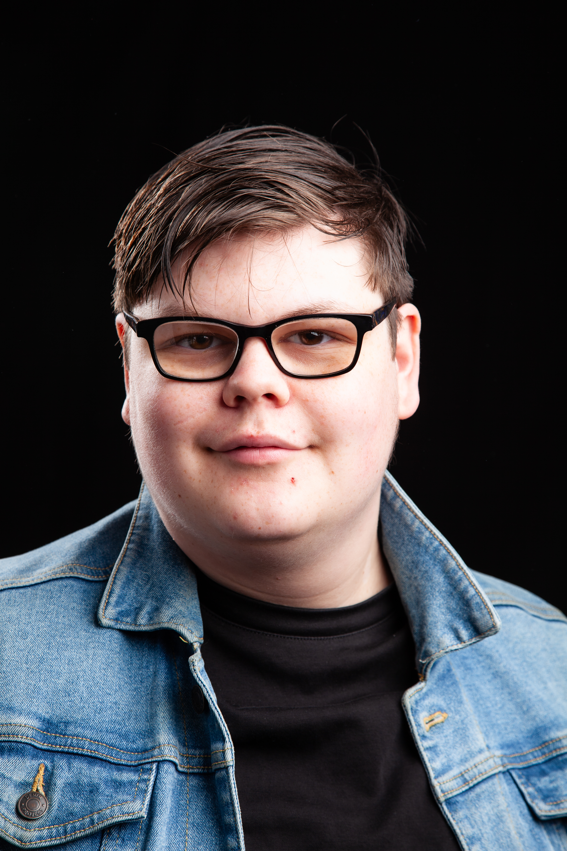
Josh prudence
Email: joshprudence01@gmail.com
Tel: 07853 364122
D.O.B: 29/08/2005 HEIGHT:5:9
EYES: brown HAIR: brown
EDUCATION: BA hons acting for stage and screen

SKILLS:
Accents & Dialects: East Anglian (Native) RP
Sports: cricket
Other Skills/Experience: worked with kids. Beginner guitar
CREDITS:
Role | Title of Piece | Director | company | Type | Year
Wizard/Grug/Ken | Monkey Bars and Metal slides | Molli Lloyd James | Northern art | Stage | 2026
Gravedigger 1/ credit card company/ cash for stuff/techie | My Mother’s Funeral | Johnathan Bussell | Alphabetti Theatre | Stage | 2026
Jeb | First Dates | Conner | Northern Art | Film | 2026
Chiron | Titus Andronicus | Dr David Edwards | Ark | Stage | 2025
Danny | Actualities | Curtis | Northern Art | Film | 2025
Junkyard storyteller | Hullabaloo in wonderland | Stan Hodgson | Hullabaloo | Outdoor theatre | 2025
Bailiff | Outsider | Dr David Edwards | Northern Art | Stage | 2024
Dad | No Particular Order | Johnathan Bussell | Northern Art | Stage | 2024

