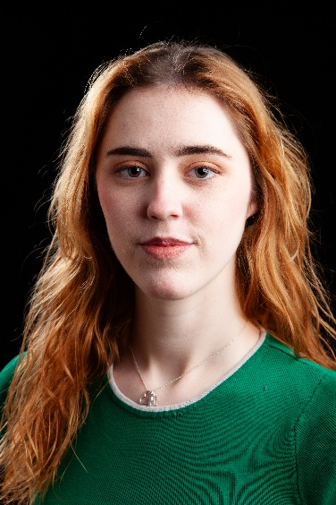
Erin Fenlon
D.O.B: 25/04/2005 HEIGHT: 5 ft 6.
EYES: Blue-Green HAIR: Strawberry-Blonde (dyed)
EDUCATION: BA (Hons) Acting for Stage and Screen @ The Northern School of Art

SKILLS: Pantomime, Devising, Comedy Improv, Cycling, Swimming, Ice Skating, Rollerblading
Accents & Dialects: Yorkshire (Native) , Standard English
Music & Dance: Singing; mezzo-soprano
Spotlight: https://app.spotlight.com/1978-9051-5409

CREDITS:
Role  Jane  Louise  Mum  Maddison  Mo/Claire/Sue  Publius  Sophie  Doctor Greenfield  Mia | Title of Piece  Sight Without Seeing  Embers  Everyday is like Sunday  First Dates  Black Teeth and a Brilliant Smile  Titus Andronicus  Add a Side of Suffrage  Solivagant  Death on the Dunes | Director  Mitch Watson  Lottie Grace Fears  Molly McKean  Connor Lovett  Steve Byron  David Edwards  Devised  Rory Norton  Jake Broomfield | Company  Northern School of Art  Northern School of Art  Northern School of Art  Northern School of Art  Northern School of Art  Northern School of Art  Northern School of Art  Northern School of Art  Northern School of Art | Type  Stage  Stage  Radio  Screen  Stage  Stage  Stage  Screen  Screen | Year  2026  2026  2026  2026  2026  2025  2025  2024  2024
Assistant | No Particular Order | Jonathan Bussell | Northern School of Art | Stage | 2024

