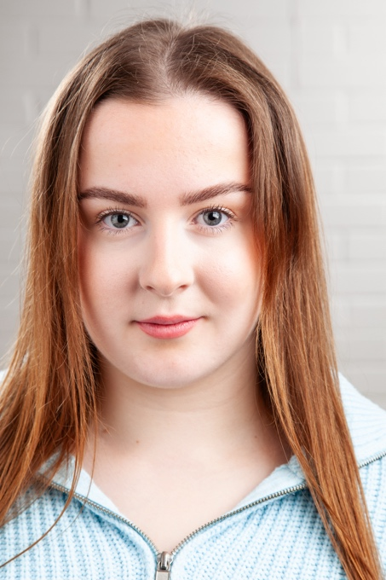
Lucy Hart-Simm
D.O.B: 12/03/2003 HEIGHT: 5’7 (170cm)
EYES: Dark Blue/Grey HAIR: Brown
EDUCATION:
BA (hons) Acting for Stage and Screen @ The Northern School of Art (Graduation 2026)
Level 4 BA (hons) Dance Performance & Teaching (2021/22)
SKILLS:
Accents & Dialects: Northumbrian (Native), RP, Geordie, Scouse, Essex, Scottish (general), American (general), Yorkshire (general), Cockney
Music & Dance: Singing (Soprano), Ballet, Tap, Jazz, Musical Theatre, Contemporary, Lyrical
Sport: Dance, Swimming
Other Skills/Experience: Dance Teacher, Acrobatics Teacher, Musical Theatre Teacher, Singing Teacher, Choreography, Car Driving license, DBS Check
CREDITS:
Role | Title of Piece | Director | Company | Type | Year
Funeral Director, ACE, SET | My Mother’s Funeral | Jonathan Bussell | The Northern School of Art | Stage | 2026
Carly | First Dates | Connor Lovett | The Northern School of Art | Screen | 2026
Sally | Wholesome | David Edwards | The Northern School of Art | Radio | 2026
Violet | Just Another Chapter | Alex Jade Wallace | The Northern School of Art | Stage | 2025
Clown | Titus Andronicus | David Edwards | The Northern School of Art | Stage | 2025
Roxie | Through the Decades | Ella Hand | The Northern School of Art Musical Theatre Society | Musical | 2025
Alex | Moth | Devised | The Northern School of Art | Stage | 2025
Arna, Morag, Sophie, Megan | Three girls, one Mith | Devised | The Northern School of Art | Radio | 2025
Woman, Reporter | The Outsider | David Edwards | The Northern School of Art | Stage | 2024
Two, Woman | No Particular Order | Jonathan Bussell | The Northern School of Art | Stage | 2024
Teacher | Troubled | Owen Burke | The Northern School of Art | Screen | 2024
Lauren | Cell Service | Max Ferguson | The Northern School of Art | Stage | 2024

