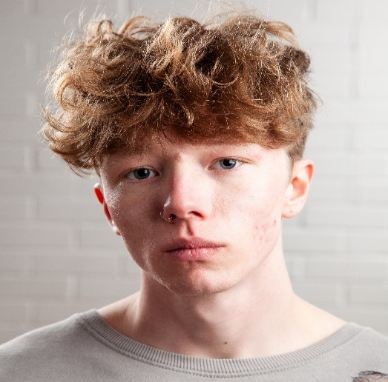
Name: Tyler Shaye Gracie
Sex: male
D.O.B: 04/01/2005 Playing Age: 15-23
Height: 5’10
Eyes: Blue

Hair: Dirty blonde/Mousey brown, short/medium (OPEN TO CHANGE)
Education: BA (Hons) Acting for Stage and Screen 2026 @ The Northern School of Art
A-Level Drama and theatre studies 2023 @ East Norfolk Sixth Form
GCSE drama (Btec Level 2) @ Ormiston Denes Academy (Distinction*)
Skills: Character acting, devising, improvisation, stage combat (basic), physical strength, core strength, basic calisthenics
Accents/Dialects: Suffolk (native), Norfolk, RP, General American, Australian, Essex, Cockney, Northern Irish, MLE
Sports: Bodybuilding
Music/Dance: singing; Baritone. Basic contemporary dance training. Music production. Rap
Credits:
ROLE | TITLE OF PIECE | DIRECTOR | COMPANY | TYPE | YEAR
SPEAKER | In Your Darkest Moments – Scratch showing | Self-directed | SIDEQUEST CIC | Stage | 2026
TYYGRR | Lad’s Lad’s Lad’s poem | Self-directed | SIDEQUEST CIC | Media | 2026
Charlie | It’s What She Would’ve Wanted | Leigha Paige | The Northern School of Art | Stage | 2026
John Doe | Hurt People, Hurt People | Ellie Mordue | The Northern School of Art | Radio | 2026
Darren Waller | My Mother’s Funeral: The Show | Jonathan Bussell | The Northern School of Art | Stage | 2026
Carl | First Dates | Connor Lovett | The Northern School of Art | Screen | 2026
JARVIS, Researcher, EVO | hAiRlEsS mOnKeYs | Self-directed | The Northern School of Art | Stage | 2026
Mark | The Six  Seconds | Noah Boyce | Independent | Screen | 2026
Police officer | The waiting room | Max Ferguson  and Elliot Robinson | The Northern School of art | Screen | 2025
Man | Mini Yacht  Advert – Hartlepool  Marina | Jake  Carpenter | The Northern School of art | Screen | 2025
James | The  Borderlines | Robert  Heselton | The Northern School of art | Screen | 2025
Kezzy | WORMTOWN | Andrew  Dawson | Customs  House  Theatre | Stage | 2025
Demetrius | Titus  Andronicus | Dr David Edwards | The Northern School of art | Stage | 2025
Gabe | A cake, a car, and what comes after | Devised | The Northern School of art | Stage | 2025
(Arab) Man/ police officer | The Outsider | Dr David Edwards | The Northern School of Art | Stage | 2024
Soldier | No particular order | Jonathan Bussell | The Northern School of Art | Stage | 2024
James | On The Rocks | Max Ferguson | The Northern School of art | Screen | 2024
Jack | Among the  Stars | Max Ferguson | The Northern School of art | Screen | 2024
Frank | I Love You, Always | Elliot  Robinson | The Northern School of art | Screen | 2024
Evan | Through the Decades | Ella Hand/  Anya  Robinson | St. George’s Theatre | Stage/  Musical | 2024
Soldier | A soldier’s vow | Liam Sankey | Chamber Films | Screen | 2023
Noah | It started off as lovers | Liam Sankey | Chamber Films | Screen | 2022
A Christmas Carol | Fred | Hannah  Morris | Ormiston  Denes  Academy | Stage | 2018

Spotlight Number: 8135-0163-6561

