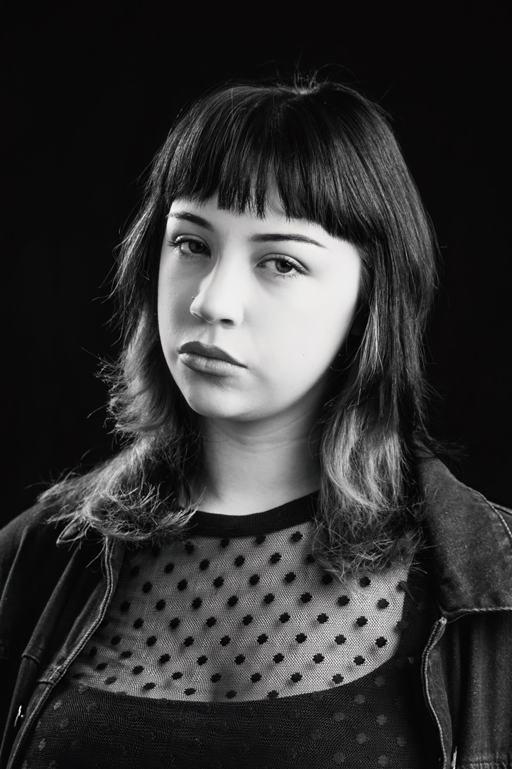
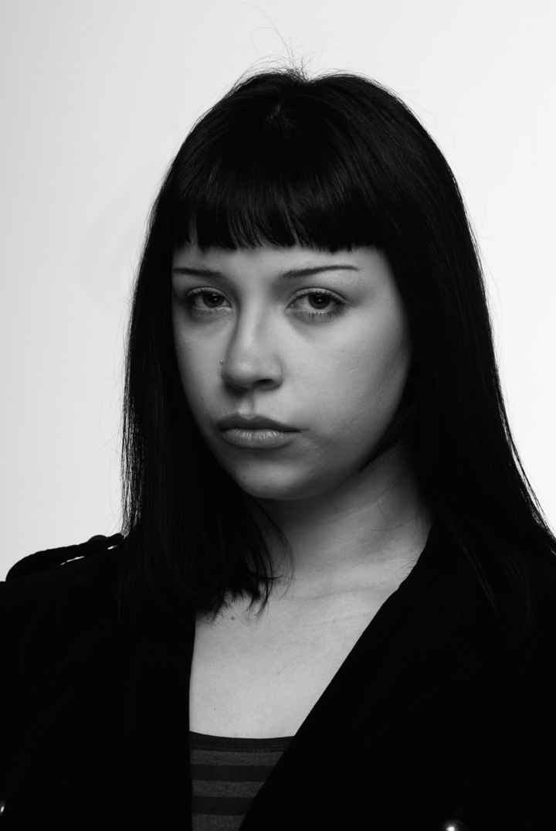
Cameron Thompson

Location: Northampton
Education: The Northern School of Art

Age: 21
D.O.B: 14/04/2005
Height: 5’8
Hair: Mid length black hair and fringe
Eyes: Dark Blue
Accent: RP
Singing: Alto
Skills: Intermediate pianist and guitarist, Beginner drummer, Makeup artistry, Modelling, Ride a bike, Bartending

First Dates | Drea | Jonathan Bussell | The Northern School of Art | 2026
My Mother’s Funeral | Mortician | Jonathan Bussell | The Northern School of Art | 2026
Passing Through | Morgan | Millie Maxwell | The Northern School of Art | 2025
Titus Andronicus | Sempronius | David Edwards | The Northern School of Art | 2025
Exhibition of Life | Billie Carpenter | Devised Work | The Northern School of Art | 2025
The Borderlines | Jennifer Campbell | Devised Work | The Northern School of Art | 2024
The Outsider | Guard | David Edwards | The Northern School of Art | 2024
No Particular Order | Couturier | Jonathan Bussell | The Northern School of Art | 2025

