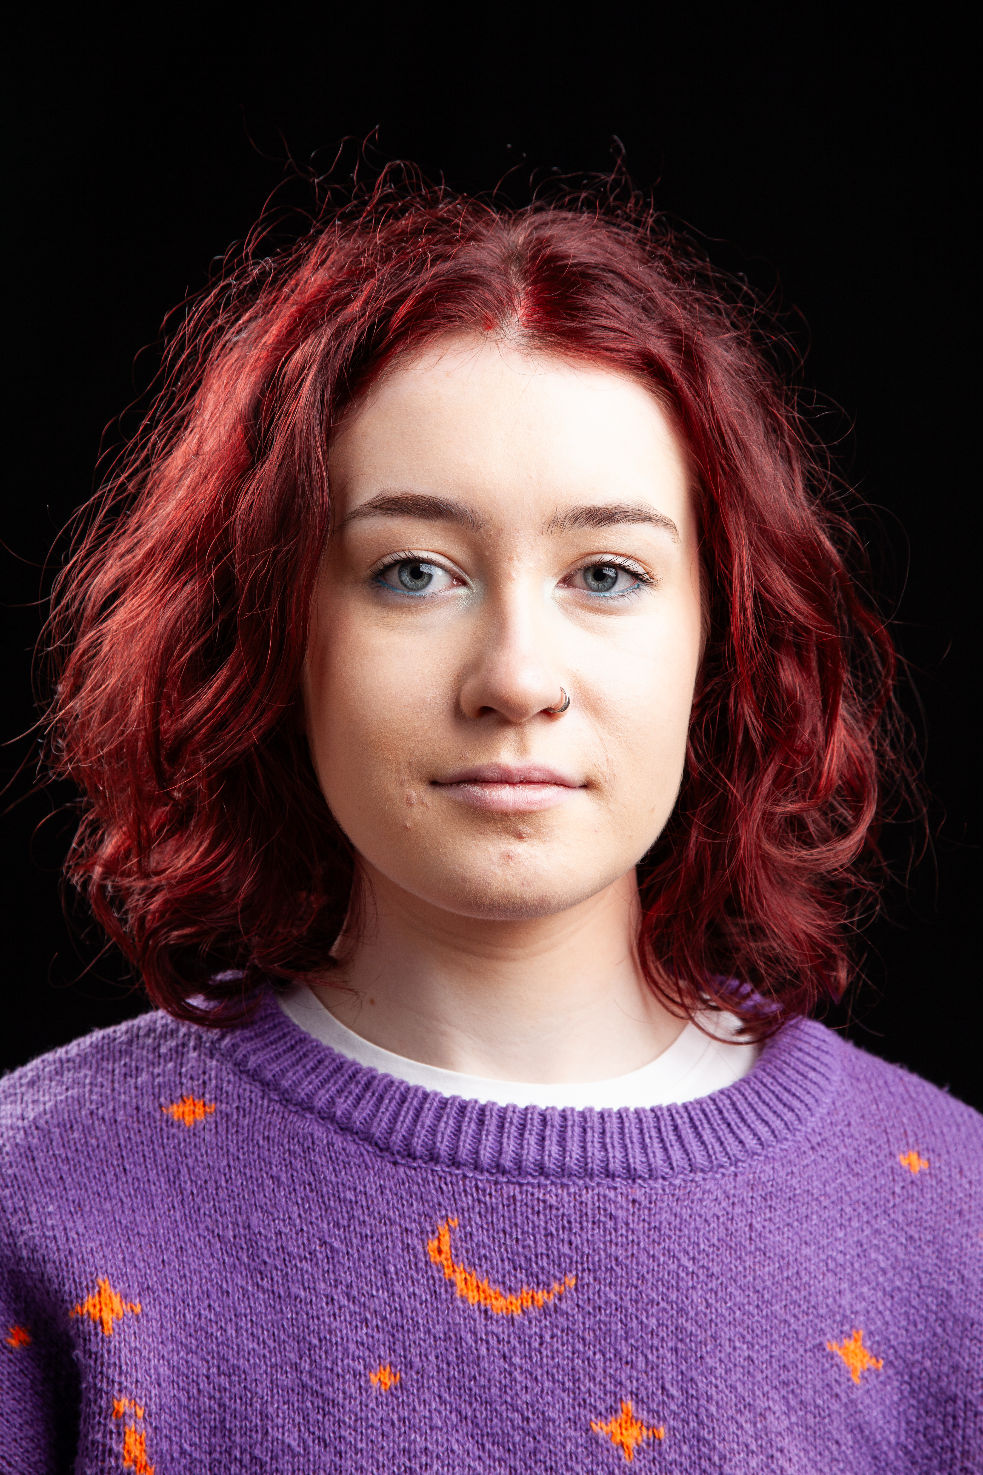
Faye Atkinson
D.O.B: 08/06/05 HEIGHT: 5 feet 3 inches
EYES: Blue HAIR: Red
EDUCATION: BA (Hons) Acting for Stage and Screen
SKILLS:
Accents & Dialects: County Durham (Native), North American
Sports: Short-Distance Running, Rollerskating
Other Skills/Experience: Working with Children

CREDITS:
Role | Title of Piece | Director | Company | Type | Year
Wendy/Leni | Joseph K | Dr David Edwards | The Northern School of Art | Stage | 2026
Elora/Throk | Verdantasia | Jake Broomfield | The Northern School of Art | Radio Play | 2026
Pearl | First Dates | Connor Lovett | The Northern School of Art | Short Film | 2026
Maya | Back in my Day | Faye Atkinson | The Northern School of Art | Stage | 2025
Banquet Guest | S&DR200 Presents Ghost Train | Bill Palmer and Chris Squire | Walk The Plank | Site Specific | 2025
Lucius | Titus Andronicus | Dr David Edwards | The Northern School of Art | Stage | 2025
Clara | Actualities | Curtis Burnett | The Northern School of Art | Short Film | 2024
Meursault | The Outsider | Dr David Edwards | The Northern School of Art | Stage | 2024
Artist | No Particular Order | Jonathan Bussell | The Northern School of Art | Stage | 2024

