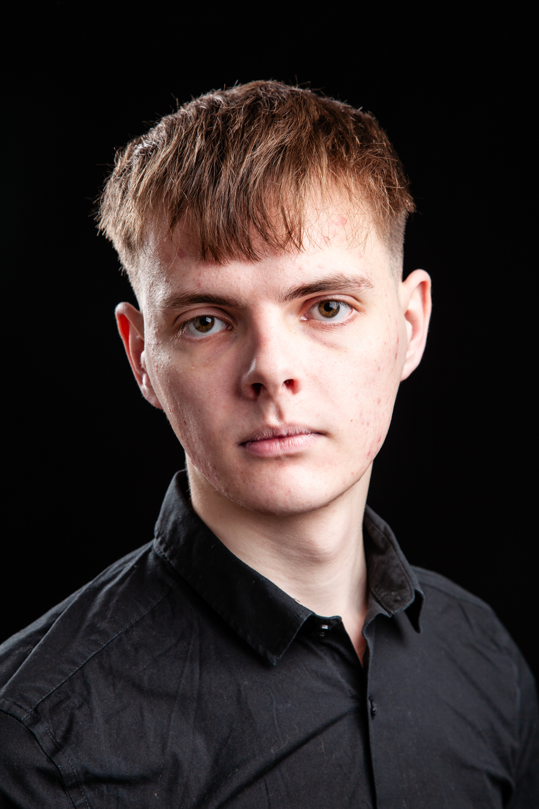
Jack Thomas
Spotlight number: 1419-8942-4467
D.O.B: 13/08/2005 HEIGHT: 6ft
EYES: Brown HAIR: Brown

EDUCATION: BA (HONS) Acting for stage and screen (Graduating 2026)
SKILLS: Drawing, writing, singing (Bass)
Accents & Dialects: Yorkshire (native)
Other Skills/Experience: Acting for screen workshop with ‘In the Frame
CREDITS:
Role | Title of Piece | Director | Company | Type | Year
Jon | Sight Without seeing | Mitch Watson | NSA | Theatre | 2026
Sam | Embers | Lottie Grace Fears | NSA | Theatre | 2026
Joseph K | Joseph K | Dr David Edwards | NSA | Theatre | 2026
Theodore | First dates | Jonathan Bussell | NSA | Film | 2026
Banquet guest | S&D 200-year anniversary Ghost Train event | Chris Squire & Bill Palmer | Walk the plank | Outdoor Theatre | 2025
Aaron | Titus Andronicus | Dr David Edwards | NSA | Theatre | 2025
Robert Greenwich | The waiting room | Elliot Robinson  Max Ferguson  Jake Broomfield | NSA | Screen | 2025
Jared | A cake, a car and what comes after | Devised | NSA | Theatre | 2025
Tyler | Roll for it radio | Devised | NSA | Radio | 2025
Joseph | Solivagant | Dr David Edwards | NSA | Screen | 2025
Harry | Life’s a gamble | LJ Watt | NSA | Theatre | 2024
Raymond | The Outsider | Dr David Edwards | NSA | Theatre | 2024
Higher dimensional being | On the Rocks | Max Ferguson | NSA | Screen | 2024
Man/ Guard | No Particular Order | Jonathan Bussell | NSA | Theatre | 2024
Teacher | I Love You, Always | Elliot Robinson | NSA | Screen | 2024
Connor | Behind Closed Doors | Owen Burke | NSA | Screen | 2024

