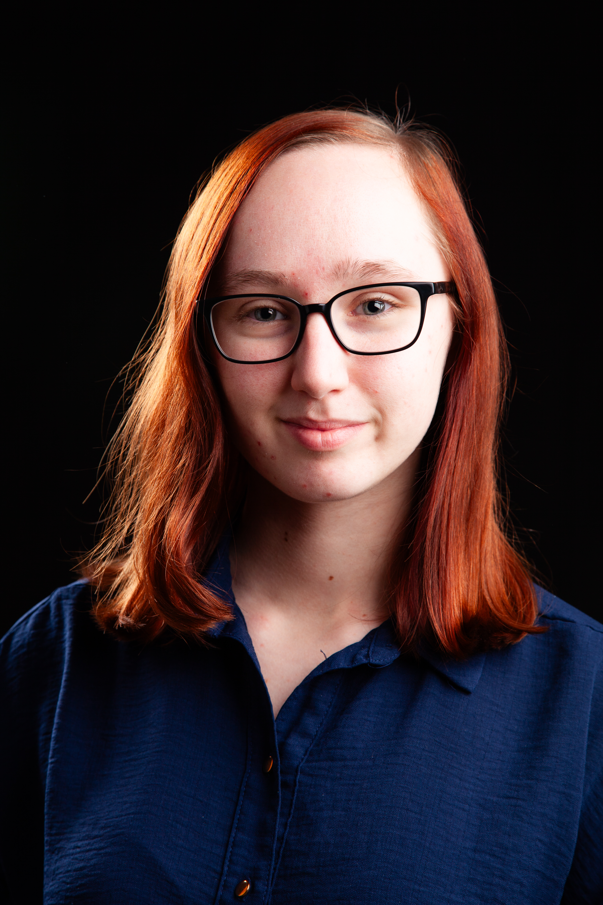
Kaitlin McPhillie
D.O.B: 19/02/2005 HEIGHT: 5ft 7in
EYES: Blue HAIR: Medium Blonde, Mid Length
EDUCATION: BA (Hons) Acting for Stage and Screen (Graduation 2026)
SKILLS:
Accents & Dialects: Yorkshire (Native)
Music & Dance: Dance (general)
Sports: n/a
Other Skills/Experience:
Writer, Working with children
CREDITS:
Role | Title of Piece | Director | Company | Type | Year
Candidate 1/ Tram Announcer/ Ice Cream Driver/ Gwenyth/ Keelan/ Instructor | Wholesome | Dr David Edwards | Northern School of Art | Radio | 2026
Teacher 3 /Sharon/ Journalist 3/ Kay | Black Teeth and a Brilliant Smile | Steve Byron | Northern School of Art | Stage | 2026
Daisy | First Dates | Connor Lovett | Northern School of Art | Screen | 2026
Charlotte | Totally Fine Without You | Chloe Rattigan | Northern School of Art | Stage | 2025
Roman Soldier | Titus Andronicus | Dr David Edwards | Northern School of Art | Stage | 2025
Ava | Add a Side of Suffrage | Devised | Northern School of Art | Stage | 2025
Presenter/ Ally | Guide to Girlhood | Devised | Northern School of Art | Radio | 2025
Amy | Actualities | Curtis Burnett | Northen School of Art | Screen | 2024
Woman/ Reporter | The Outside | Dr David Edwards | Northern School of Art | Stage | 2024
Prisoner | Forgive Me Father | Jack Wilkinson | Northern School of Art | Screen | 2024
Three | No Particular Order | Jonathan Bussell | Northern School of Art | Stage | 2024

