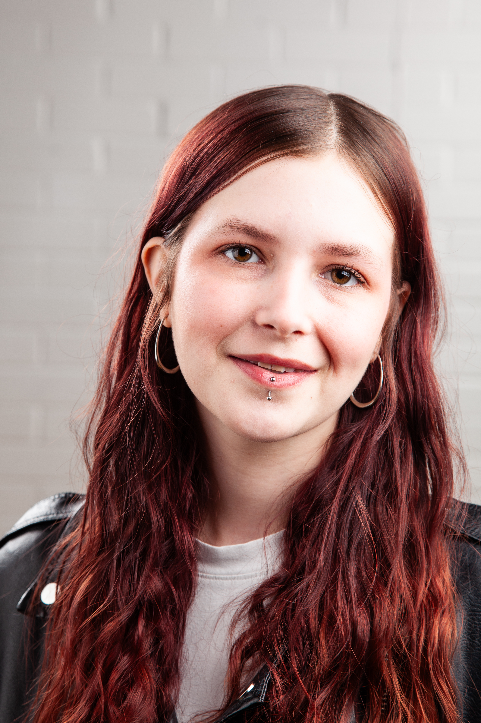
Acting CV
Name: Leigha Paige
D.O.B: 28/01/2005 HEIGHT: 5’5”
EYES: Brown HAIR: Brown/Purple
EDUCATION:
BA (Hons) Acting for Stage and Screen - Northern School of Art

SKILLS:
Accents & Dialects: East Midlands, RP, Cockney
Sports: Brown belt (Shotokan Karate)
Other Skills/Experience: Experience working with children

CREDITS:
Role | Title of piece | Director | Company | Type | Year
Abigail | My Mothers Funeral | Jonathan  Bussell | Northern School of Art | stage | Ongoing 2026
Alex | Sigmund Freud is ruining my life | Leigha  Paige | Northern School of Art | Stage | 2025
Narrator 3 | A Tail for our Future | Elen  Bodey | Newcastle Fringe | stage | 2025
Lavinia | Titus Andronicus | David  Edwards | Northern School of Art | Stage | 2025
Rebecca | The Waiting Room | Jake Broomfield | Northern School of Art | Screen | 2025
Dormouse | Hullabaloo in the park | Stan  Hodgeson | Theatre  Hullabaloo | Stage | 2024
Lawyer | The Outsider | David  Edwards | Northern School of Art | Stage | 2024
Elizabeth | The Crucible | Matthew  Dempsey | Tresham  College | Stage | 2023

